The Two Keys

**Key 1.** We've been writing, studying the Bible: the plan-writing notes of Sunday sermons, writing courses, conferences and sessions of Bible study. Over time, these documents, commentaries, notes, and other related information become very difficult to manage. Sometimes, while reading or studying a portion of Scripture, we recall that we may have previously studied the passage and taken notes. We think, "It would be great if there was a chance to see all my notes for this passage in one place, or be able to cross reference notes about a certain word in the passage..."

**Key 2.** Each of our notes or comments are related to a particular topic. Biblical references mentioned in notes are discussed within the framework of each particular topic. That is, they relate to each other within a certain context. If we are able to view all our notes and comments related to a specific place of Scripture, then we can consider this Scripture from the viewpoint of different themes and interpret the passage from the perspective of other places of Scripture. Said differently, we can form use our previous learning about a Bible passage to form its own system of cross-referencing!

God has helped bring these two keys to reality!

Getting Started

First, you will need to install Microsoft OneNote 2010 or 2013 (earlier versions is not supported). Next, you will need to download an additional software installer for the study of the Bible from the site http://IStudyBibleTools.com and install on your computer. After software installation, you will be asked to select or create notebooks needed for the program:

1. Notebook "Bible" - contains the entire text of the Bible. Here you can highlight keywords and use a special command to write comments on specific biblical passages. In other words - this is your complete electronic version of the Bible for self-study.
2. Notebook "Bible Study" - contains all your Bible notes (e.g. notes from previous Bible study courses, sermon notes, lesson plans, etc.). It is recommended that you create separate section groups for each course. This clear structuring and organization of your study materials will save your time and effort.
3. Notebook "Comments to the Bible" - contains the added commentaries to the Bible.
4. Notebook or folder "Summary of Notes" - contains pages which are created automatically with the aid of the specific command of the analysis of notes.

Details of how to use OneNote and the program OneNote IStudyBibleTools for self-study of the Bible are contained in this manual.

God bless you in this fascinating journey through His Word!

Table of contents

I. About the Program 4

II. Benefits 5

A. Benefits of OneNote 5

1) Good Structuring 5

2) Storing all information in one place 5

3) Easy Search 5

4) The possibility of tagging 5

5) Create hyperlinks 5

6) Sync via the Internet 5

a. Ability for multiply users to edit 5

b. Save in the case of computer failure 6

c. Ability to work on multiple computers 6

d. Ability to work in restricted mode without having the appropriate software (web browser) 6

B. Advantages of Using OneNote for Bible Study 6

1) Ability to add an unlimited number and size of comments on the Bible 6

2) Use of an electronic analog of Inductive Bible Study, supplemented by special program OneNote IStudyBibleTools 6

3) Single point of access to all comments, notes, lectures, courses, synopses of sermons - Bible text in OneNote 6

III. Description of Features of OneNote 8

A. Getting Started with OneNote 8

1) Creating a Notebook 8

2) Closing a Notebook 14

3) Saving a Notebook 15

4) Creating a Section and Section group 17

5) Creating a New Page 18

6) Creating Tables 19

B. Setting up synchronization through the Internet 19

1) Information about synchronizing notebooks 19

2) Checking the status of synchronization notebooks 19

C. Managing the hierarchy of pages 21

D. Formatting Text 27

E. Draw and Quick Access Toolbar 29

F. Search 30

G. Tagging 33

H. Creating Hyperlinks 36

I. Copy / paste 38

J. Page Versions 39

K. Keyboard shortcuts in OneNote 40

1) Working with text. 40

2) Working with lists 40

3) Working with tables 40

4) Global commands 41

5) Working with Pages 41

6) Search for notes 41

IV. Description of Additional Program OneNote IStudyBibleTools 42

A. Open a Verse 42

B. Write a Comment 42

1) Comment on a chapter of the Bible 42

2) Comments on a specific word in the Bible 43

C. Notes Analysis 45

D. A quick analysis of the current page 51

E. Search in dictionaries 51

F. Unlock the current book / Unlock the Bible 52

G. Parameters 53

H. Information 64

I. About Module 64

J. Recommendations 65

V. Frequently Asked Questions 73

Guide to OneNote IStudyBibleTools

# About the Program

OneNote is a software program that utilizes digital notebooks for gathering, organizing, and sharing information. OneNote allows you to store, access, and work together with information in one easily accessible location.

OneNote allows you to work with text and image, as well as video and audio notes. OneNote allows you to share notebooks so that multiple users can contribute additional information, edit notes, and be up to date with the most current notebook version.

OneNote allows flexible configuration and can be easily adapted to the accepted style of work. This means that OneNote is an excellent application for inductive Bible study.

OneNote for inductive Bible study is a digital notebook that helps users deal with information overload. Unlike paper-based notebooks, editors, and other programs, OneNote provides a flexible way to collect and organize notes taken from sermons, courses, seminars, conferences and meetings. These can all be collected, organized, and shared in one digital notebook on your computer.

Using OneNote IStudyBibleTools to study the Bible allows you to:

* organize all your collected information associated with the study of the Bible;
* automatically create your own system of cross-references with explanations;
* record comments on the Bible;
* ensure fast access to all stored information;
* use the computer as a complete electronic version of Inductive Bible Study.

Many have begun to use the OneNote, and we hope that soon you will enjoy the full benefits of this tool!

# Benefits

## Benefits of OneNote

### Good Structuring

OneNote uses the familiar structure of notebooks consisting of sections and pages. With the application OneNote you can view the notebooks and thanks to the convenient navigation, handy opportunity of chapters management and multilevel groups of pages, you can manage them effectively.

On the navigation bar are tools that simplify the ordering of the notebooks and the transitions between them. You can also use an expanding groups of pages in order to improve the structure and arrangement of notes. With the help of tools for working with sections, you can easily find and copy section, as well as combine multiple sections. Moreover, OneNote also has the ability to insert new pages anywhere in the hierarchy of pages.

### Storing all information in one place

OneNote allows you to keep all information in one place. It can neatly organize information or simply store it as a single bulk amount (if it is more convenient).

### Easy Search

With the Search function you can retrieve needed fragments. OneNote also has a quick way to access the most frequently used pages in your notebook. Search results are displayed directly when you type a query. In addition to searching the contents of one page, you can search the entire notebook, section, and all documents. You can also perform a quick search on the names of notebooks, sections and heading labels of pages. Authors can quickly find pages of recently added content (for the last day, week, month, etc.) or view the changes made in any given day.

You can find any phrase or any of the words. Moreover, OneNote can search for words, fragments, and various endings in a variety of forms.

### The possibility of tagging

Tags in OneNote make it easy to locate important elements in all notes. Tags can be labeled as definitions, key points, issues, people's names, and other custom labels.

### Create hyperlinks

Links in OneNote make it quick and easy to reference relevant content, such as notes, pages, sections, and section groups in your notebook. You can automatically create links to new content so that others who work with the same notebook can instantly find information in the right place.

### Sync via the Internet

Ability for multiply users to edit

OneNote provides a common point of access to notebooks and allows multiple users to access notebooks and edit them. Users can edit and view all at once, even without a network connection.

Every time someone changes a page of a shared notebook, OneNote automatically synchronizes the changes so that the notebook always contains the latest information for all users. The most recent changes are automatically highlighted. In addition, each change automatically tagged by user. This allows you to see the history of changes made to the shared notebook.

Versioning function allows you to view the version history with date and author. If a user accidentally deleted or moved content, you can refer to this journal and undo the changes.

OneNote also maintains a separate copy of your notes in a standalone mode for each user's computer. Therefore, users working on notes may continue to change them locally, even if temporarily disconnected from the network. The next time they connect to the network, OneNote automatically merges their changes with changes made by other users.

Save in the case of computer failure

There is no "Save" button on the toolbar, as the notes in OneNote are automatically saved. Moreover OneNote allows you to recover previous versions of pages, in case someone changed the notes you happen to need.

Ability to work on multiple computers

OneNote allows you to customize notebooks for use on multiple computers. OneNote provides automatic synchronization of changes from any computer.

Ability to work in restricted mode without having the appropriate software (web browser)

There are often situations when data are required from a notebook, but you are away from your computer. OneNote Web App - a web-based addition to OneNote, allows use of its functions via a web browser. You can store your notes online and edit them in your web browser to quickly view and copy the data, highlight changes made by the author, open previous versions of pages, and even edit shared notebooks simultaneously with other users of OneNote Web App and OneNote.

## Advantages of Using OneNote for Bible Study

### Ability to add an unlimited number and size of comments on the Bible

Using the recorder OneNote, you can quickly enter notes during sermons and Bible study courses, record emerging ideas, interpretation, etc.

### Use of an electronic analog of Inductive Bible Study, supplemented by special program OneNote IStudyBibleTools

OneNote is a great program that will allow you to have all the notes in one place. The entire Bible, and everything connected with the study of the Bible (courses, the plan notes, sermons), can be stored in OneNote in a structured way. But that's not all!

For the convenience, OneNote was supplemented by a special program that includes the commands:

1. The first command opens OneNote at the specified location of the Bible, making it very easy to navigate. There is no need to spend time searching for the book, then the chapter, then the specific verse. Users can just provide a link from the Bible and the program will move quickly find the note or passage.
2. The second command lets you add comments to specific biblical passages or specific words in these passages. The size of such comments is unlimited, in contrast to the fields of paper Inductive Bible Study. In addition to comments, you can add audio or video.
3. And the most interesting: the third command analyzes **all notes** and links them to specific places of the Bible, referred to in the notes themselves. Now, reading the Bible in OneNote, users can always look at any notes from previous courses, sermons, and Bible studies, that refers to a particular scripture. In this way users are gradually building their own system of cross references. And they can easily and quickly use it to interpret difficult passages the Bible.

### Single point of access to all comments, notes, lectures, courses, synopses of sermons - Bible text in OneNote

Thanks to the OneNote you can always have your Bible handy with your own personal comments, notes, and interpretations. Now, you can share it with others. Having all the necessary information at your fingertips, you'll be fully prepared ready for any upcoming study.

# Description of Features of OneNote

## Getting Started with OneNote

OneNote - a place of gathering, organizing, searching and sharing notes, clippings, ideas, reference materials, etc. For convenience, notes are organized by notebooks, sections, and pages *(Fig. 1)*.

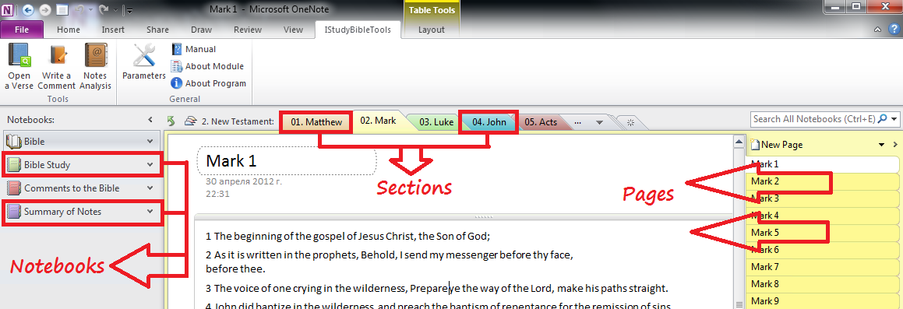

### Creating a Notebook

In order to create a notebook in OneNote, you must open the tab "File" *(Fig. 2)*.

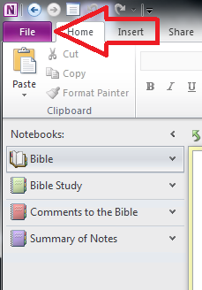

Opening it, we see a screen called Backstage view *(Fig. 3).*

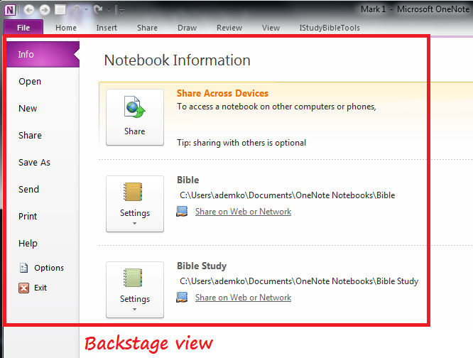

Using the tab "File", users can change from normal mode to Backstage view mode and back. To return to normal, you can open any other tab on the ribbon.

Note that in the Backstage view, clicking the "Exit" at the bottom *(Fig. 4)*

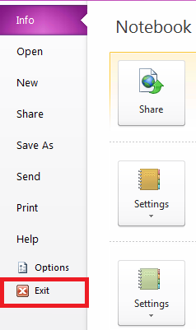

does not return the user to Normal mode of OneNote. If you press this Exit button, it will close the entire program and then it will open again.

In Backstage view work is done with a notebook as a whole. In addition to creating a notebook in Backstage view, you can see options of any opened notebook and open existing notebook, which was closed earlier. So, to create a notebook, it is necessary to select the tab "Create" in Backstage retained view *(Fig. 5).*

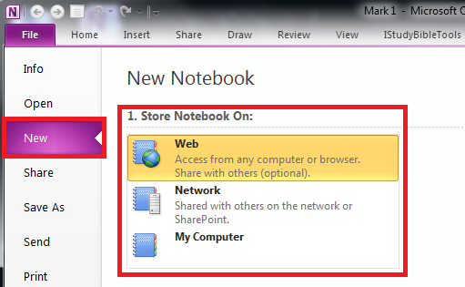

On this tab, you specify where you want to keep a notebook:

1. Note that if you select the location using "Web", the new notebook will be retained in SkyDrive[1] *(Fig. 6).*

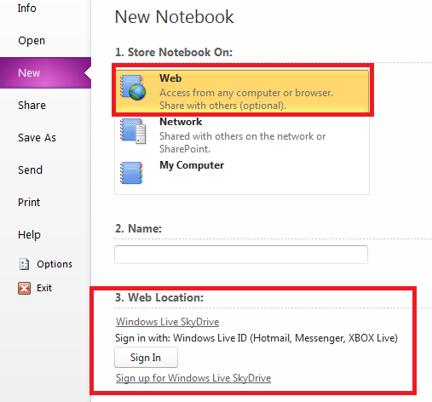

If you save a file in this service, you can access it from any computer. If necessary, you can give access to other users to the notebook stored in the SkyDrive. To use this service you will need a Windows Live ID[2].

1. If you want to grant access to your notebook only to other users of your network, you can save the book on the "Network" *(Fig. 7).*

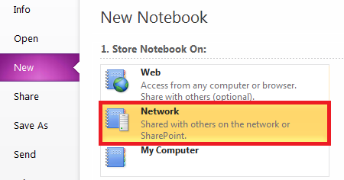

1. If a book is created for personal use, you can choose the third option, "My Computer" *(Fig. 8).*

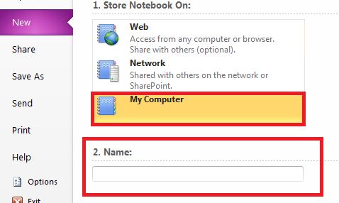

Next, you must specify the name of the new notebook *(Fig. 8)* and specify the folder *(Fig. 9).*

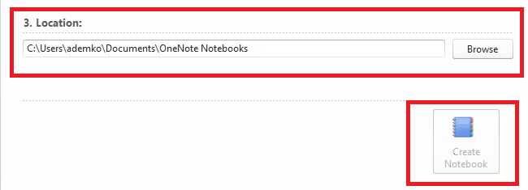

After configuring all the settings, press the button "Create Notebook" *(Fig. 9).*

If you want to change the color of your notebook, it is necessary for the navigation bar, right-click the created address book and select the context menu "Properties…" *(Fig. 10).*

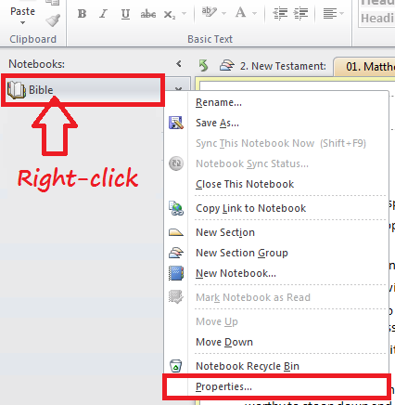

This opens a dialog box where you can set or change various properties of the notebook. You can change not only the color of the notebook, but also notebook location, display name, and format (*Fig. 11*).

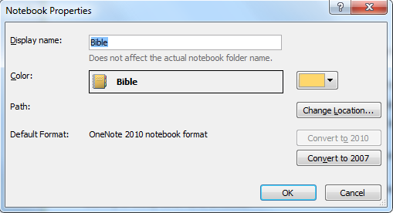

If you want to change access to existing OneNote notebooks (for example, place the notebook on the Internet), follow the instructions below:

1. In the "File" menu, choose "Share" *(Fig. 12).*

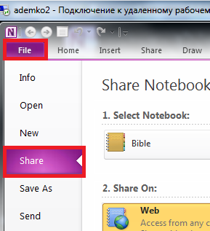

1. In the "Select Notebook", you must specify an existing notebook to which you wish to provide access *(Fig. 13).*
2. Under "Share On" select location where notebook access will be granted *(Fig. 13).*

* Select "Web" if you want to grant notebook access to users from any computer or web browser.
* Select "Network" if you want to grant notebook access to other users or computers on the same network.

1. After choosing "Web" or "Network" location, do one of the following *(Fig. 13)*:

* Web Location. If Web service is available, sign in using your Windows Live ID, or register a new one. After you log on, you will see a list of web directories where you can create shared notebooks. If you need to provide access to other users not listed, select one of the personal folders. You can also select a shared folder, which will be accessed by other users. To set permissions for new and existing folders, OneNote will open a web browser, where you can create the new folder for your notebook. Return to OneNote and update the list of folders in the "Web" location to find the folder you just created. Then select the folder.
* Network Location. You can specify the full path to a network shared folder, which will create a shared notebook. Keep in mind that the notebook will be available to all users who have permission to access this network.

1. Click "Share Notebook" *(Fig. 13).*

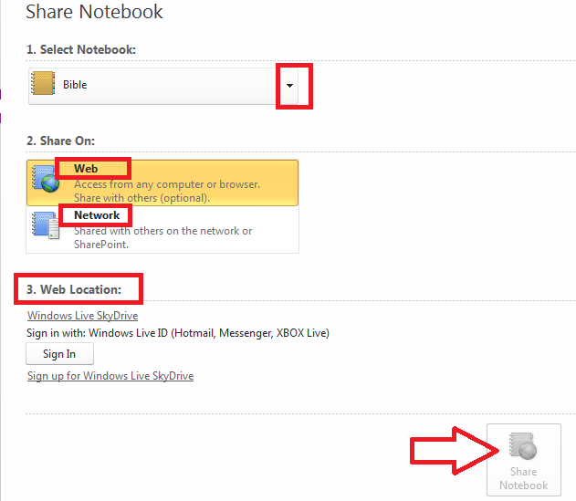

If the options "Web" or "Network" is not available, check the connection to the Internet or a network and the availability of the necessary permits.

### Closing a Notebook

Please note that you rarely need to close notebooks. Usually it makes sense to keep all of your notebooks open. First, when notebooks are open, you can work with them and also view data. The search function in OneNote allows you to search only data in the currently open notebooks. Second, every time you close and reopen the notebook it runs a full synchronization and re-indexing. Therefore, it is recommended to close the address book only if it is no longer being used and does not require use of any navigation bar tools or search results. To close the notebook, you must first be in Normal mode and then click on the navigation bar. Then select the Context Menu and "Close this Notebook" *(Fig. 14).*

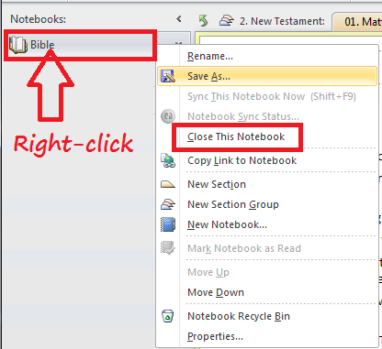

Also, you can close any notebook using Backstage view. To do this, open the tab "Info", then click the arrow on the button for the address book you want to close, and then click "Close" *(Fig. 15).*

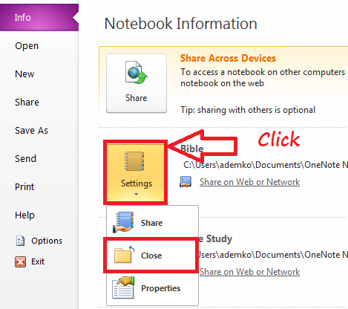

### Saving a Notebook

OneNote automatically saves your work continuously during the creation of notes, when you switch to another page or section, and when closing sections and notebooks. There is no need to manually save a note after finishing work on them.

To save a copy of the notes section in a different location, you must perform the following steps:

1. In "File" choose "Save As" *(Fig. 16).*
2. In "Save Current", do one of the following *(Fig. 16)*:

* To save the currently open page, select "Page".
* To save the currently open section, select the "Section".
* To save the currently open notebook, select "Notebook".

1. In "Select Format" to select the desired file format *(Fig. 16).*
2. Click the "Save As" *(Fig. 16).*

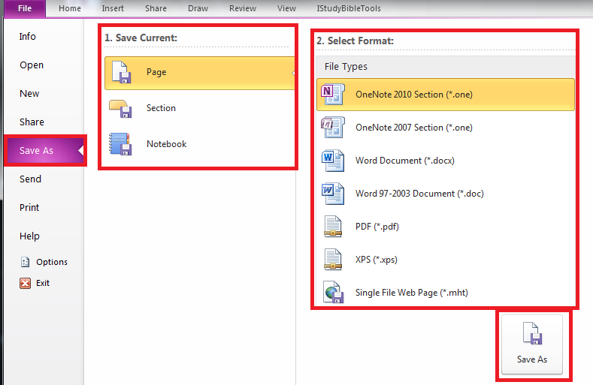

1. In dialog box "Save As", select the folder where you want to save the file *(Fig. 17).*
2. In "File name" type the name of the notebook *(Fig. 17).*
3. Click "Save" button *(Fig. 17).*

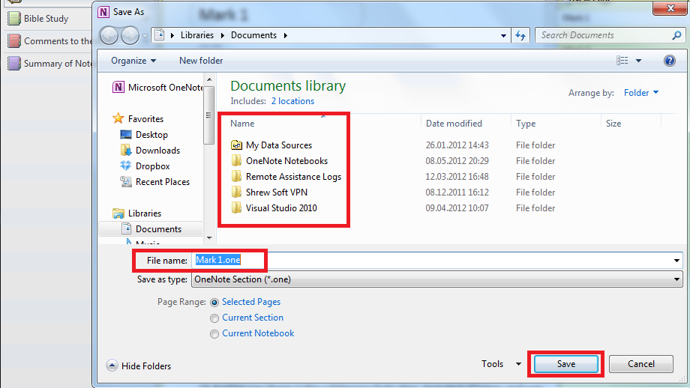

### Creating a Section and Section group

If your records are filed according to a particular subject or course, you can create a section in your notebook or section group for each of these courses *(Fig. 18).* Similarly, a section group is a folder (in each group of sections there may be as many sections as you want). Similarly, a document serves as a section.

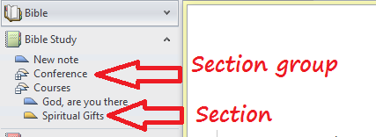

To create a section/section group, you can choose from the menu "New Section"/"New Section Group" *(Fig. 19).*

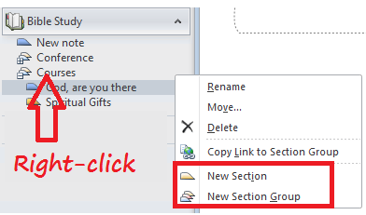

### Creating a New Page

To create a new page, use the button "New Page" *(Fig. 20).*

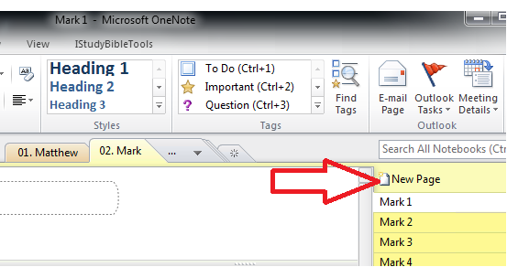

Also, by clicking "New Page", you can add a new page, subpage or a page from a template *(Fig. 21).*

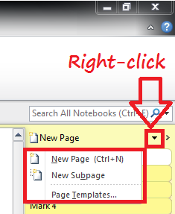

There is yet another way to create a new page. If you hover your mouse over the tabs page, there is a small page icon with an arrow *(Fig. 22).*

Move the mouse up or down the list until the thick black line is positioned where you would like the new page to be located. To create the page, just click on the icon to the left of the thick black line. A new page will appear in the place where the thick black line *(Fig. 22).*

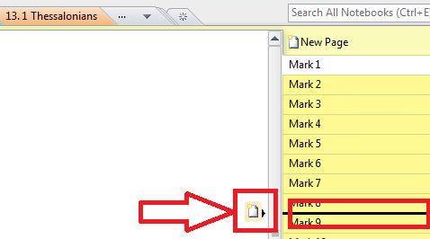

### Creating Tables

To create a table, you must first type the name of the first column of the table. Press TAB and then type the name of the second column of the table. Again, press the TAB key and enter the name of the third column of the table, and so on. When you have inserted all the columns, press the ENTER key. You can then move between cells by using the TAB key. After finishing a row of a table, press ENTER. To move to the next row of a table, you can use the keyboard shortcut Alt + Enter. To go to the bottom row of a table, you can use the keyboard shortcut Ctrl + Enter.

## Setting up synchronization through the Internet

### Information about synchronizing notebooks

When working with notebooks that are stored on your computer, OneNote continuously saves changes automatically as you work.

However, when creating a shared notebook on the Internet to collaborate with other users on other computers, the conservation and management of change is somewhat different. OneNote keeps a local cached copy of a shared notebook on each computer that accesses it, and then periodically synchronizes changes to files in each notebook, which are then stored in a shared location. It is possible to change the settings of this process. In order to ensure changes made by all users are saved, you need to resolve certain conflict changes as they arise.

In order to synchronize shared notebooks, users must launch OneNote. If your computer is on, but OneNote is closed, shared notebooks will not be synchronized.

### Checking the status of synchronization notebooks

Under normal conditions, OneNote automatically synchronizes shared notebooks at regular intervals. In the navigation area icons display the synchronization status of OneNote shared notebooks *(Fig. 23).*

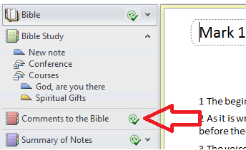

The meanings of the are icons listed below:

1. OneNote has finished synchronizing changes *(Fig. 23).* The icon with two green arrows in a circle and a green check mark is displayed when changes are synchronized with the files in your notebook in a general location. After synchronization is complete, other users can view the latest version of the notes.
2. OneNote will sync the changes *(Fig. 24).*



The icon with two green arrows in a circle appears when OneNote is trying to sync changes to the file in your notebook to a shared location.

1. Failure in OneNote to sync changes *(Fig. 25).*



If errors occurred during the last attempt to sync, an icon with a yellow warning symbol appears in the form of a triangle. To view information about the reason for failure, right-click the shared notebook in the Navigation Pane and then click Sync Status of the notebook.

1. OneNote cannot sync changes *(Fig. 26).*



An icon with a red slashed circle appears when the connection to the desired storage location fails. Perhaps there is no connection to the server or a remote location is not responding. If there is no connection, you can change the local copy of the shared notebook on your computer. Changes made while offline are automatically synchronized the next time you connect to a common location.

If a common network location is temporarily unavailable, or view the current changes in the notebook made by other users are not wanted, you can disable the automatic synchronization of your notebook by following these steps.

1. Right-click on the icon and select "Notebook Sync Status" *(Fig. 27).*

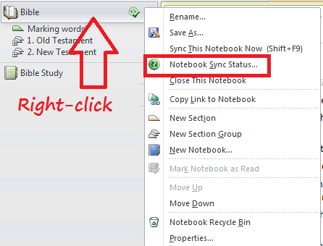

1. In the dialog box "Shared Notebook Synchronization", select "Work offline - sync only when I click Sync All" *(Fig 28).* OneNote will not synchronize notebook changes made by other people until automatic synchronization is manually enabled.

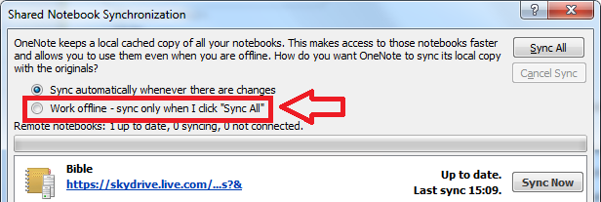

## Managing the hierarchy of pages

In OneNote, in addition to sections and section groups, there are three levels of hierarchy: main pages, first-level subpages, and second-level subpages. This structure is flexible and convenient in terms of ordering the material. To determine the type of page, you have two options. First, each type requires its own shade of color. The main page is the darkest, and the second-level sub-pages are the lightest. Secondly, the names of the sub pages of both levels are indented *(Fig. 29).*

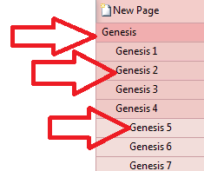

To reduce the hierarchical level of a page (for example, to turn a main page or a first level subpage into second-level subpage), just drag the page name on the label to the right half or the end *(Fig. 30).* To increase the hierarchical level of a page, drag the page name to the left half or end position *(Fig. 30).*

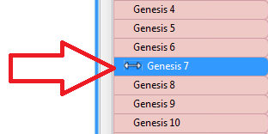

To move a page down one level, you can use the menu command "Make Subpage". To move a page up one level, you can use the menu command "Promote Subpage" *(Fig. 31).*

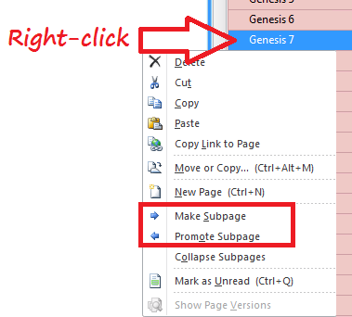

In order to highlight the main page and all its sub-pages, you need to select any page in the group, and then double-click it. This selects the entire group *(Fig. 32).*

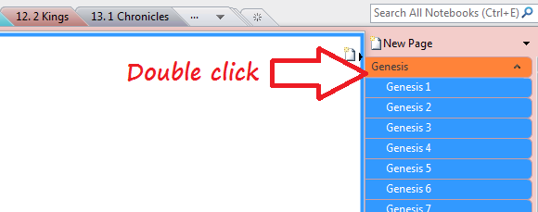

Minimize and maximize button is displayed on all main pages with nested pages. If you hover the mouse pointer over the main page, you can collapse or expand all group *(Fig. 33).*

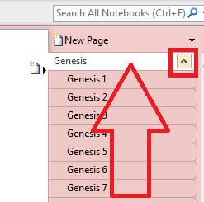

There are visual signs to you understand what you are seeing when viewing a collapsed group of a main page and its subpages.

1. First, the main page of the nested group is displayed on the navigation bar, not only when you hover the mouse pointer on it *(Fig. 34).*

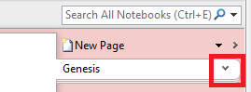

1. Second, if the group is collapsed, the edges of nested pages peek out from under the bottom edge of the main page *(Fig. 35).*

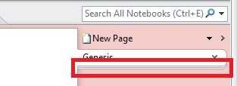

In order to move or copy a page or group of pages, you can select them and drag to the new location. For example, to move a page to another location in the same section, you can simply drag it until the thick line is in the desired location, and release the mouse button *(Fig. 36).*

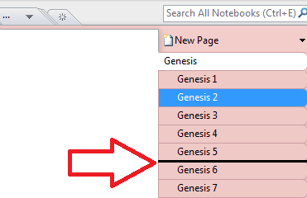

It is possible to move or copy a page can be moved another section of the same notebook, or in any open notebook, by dragging it on the navigation bar. While moving or copying the page, it is only necessary to designate the appropriate section of the notebook before releasing the mouse button. To copy one or more pages to another location, while at the same time saving them in the original location, you must hold down the CTRL key while dragging. The copied page will now be in both places. To cancel a dragging or dropping an item, press ESC.

Tip: Before you move or copy may be convenient to collapse a group of pages and sub-pages. As a result, it may be easier to move or copy the pages together. Users who prefer to work with dragging dialog boxes can simply right-click the object you want to copy or move, choose the context menu "Move or Copy…" (*Fig. 37*)

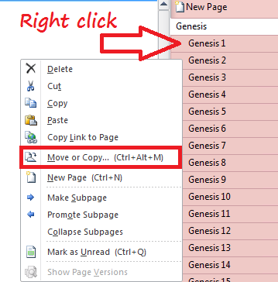

and set the necessary parameters in the dialog box "Move or Copy Pages" *(Fig. 38).*

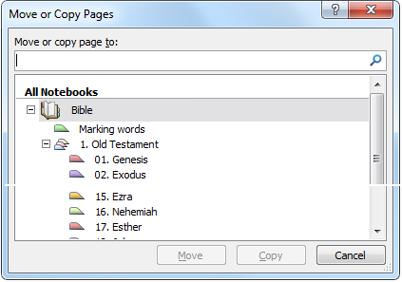

In OneNote, you can drag entire sections and section groups to other places using the tabs section *(Fig. 39),*

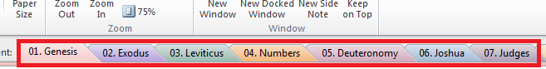

and on the navigation bar *(Fig. 40).*

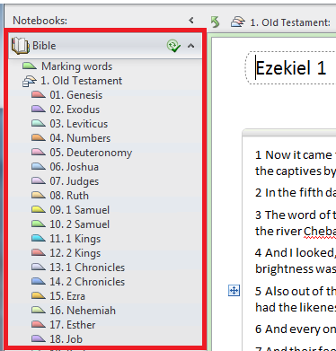

Always pay attention to the black triangle or line *(Fig. 41),* which indicates the exact final position of the dragged object.

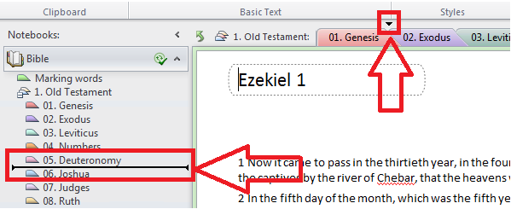

If you want to copy a section or sections of a group while keeping them in the original location, hold down the CTRL key.

In addition, you can use the OneNote dialog box "Move or Copy…" *(Fig. 42).*

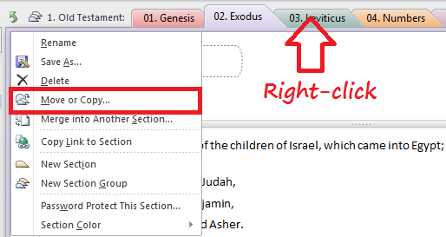

It is very similar to the dialog box "Move or copy pages", which we reviewed earlier.

There is a function called "Overflow sections", making it easy to work in a situation where there are too many sections and they do not fit on a page of notes. Just click the arrow on the label with a dot to see a list of sections and section groups at this level *(Fig. 43).*

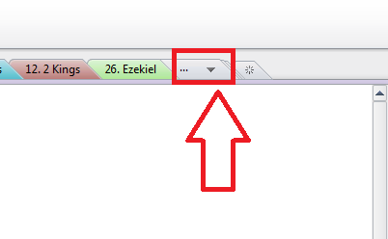

In order to open a specific section or section group, click the appropriate item. A similar overflow feature is provided in the navigation bar, but is available only if the navigation bar is collapsed *(Fig. 44).*

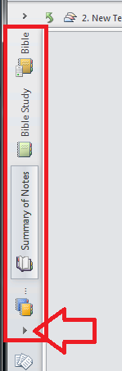

## Formatting Text

OneNote allows you to record notes from top to bottom, as in a text editor, or use the entire field of the page to place entries in random order. If the notes are inserted and maintained throughout the same page, they are separately located and can be moved.

One of the basic operations of OneNote is formatting text notes. Notes can be formatted in several ways.

You can select the text you want to format by clicking the right mouse button. In this case there are two objects: the context menu, and the mini-toolbar *(Fig. 45).*

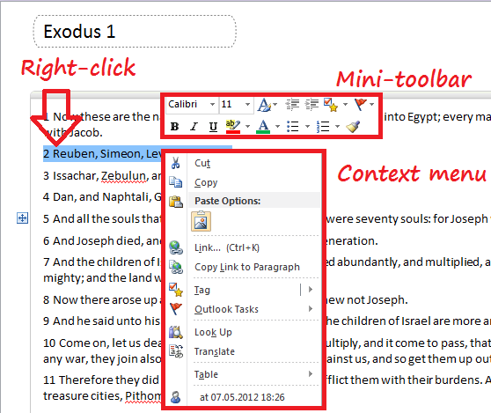

Using the Mini-toolbar, you can change the font and size or apply bold face, italics, underlining. You can also highlight text and change its color as well as change margins and format bulleted and numbered lists.

Another useful feature of the mini toolbar is the ability to add tags. A formatting function example is located on the mini-toolbar (*Fig. 46*).

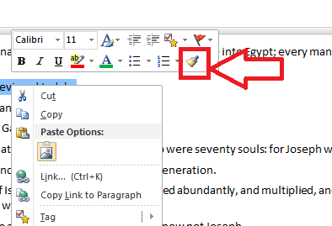

To use the formatting example, choose the "Format Painter" and highlight the text you want to format. You can apply formatting to multiple fragments by double-clicking "Format Painter" when the text is selected. You can then select the target fragments, one by one. After copying the desired format, press ESC, to turn off example formatting.

Other formatting options can be found on the ribbon. To do this, click on any of its tabs. Let’s consider the ribbon (command bar) in more detail.

The first time you run OneNote the ribbon is displayed *(Fig. 47).*

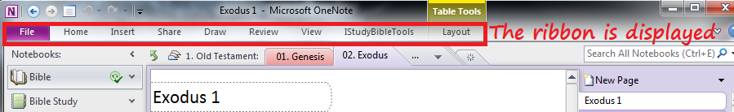

Notice that there is plenty of room for more notes. When the tape is minimized, it is possible to see the tabs. As soon as you click outside of the tab, it closes again. However, if you expand the tape by pressing the maximize button *(Fig. 48)*, the selected tab will be fully visible. The user can decide in what form - minimized or maximized - to display tape. When it is necessary to use a lot of options and commands, you can maximize the ribbon, but if you just need to write notes, you can maximize the tab and page to display more text without scrolling.

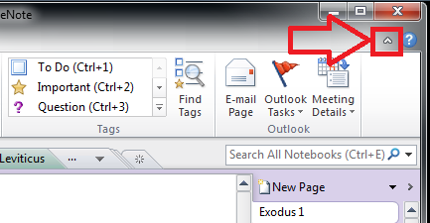

Most text formatting options are on the tab "Home" *(Fig. 49).*

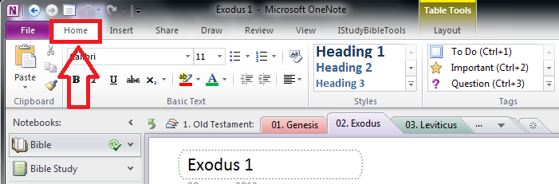

Tip: Use the right mouse button often in OneNote - a very good habit. If you do not know what to do to perform a required operation, right-click on the appropriate object and see what happens. Very often, this way you can find the answer in the context menu.

One of the advantages of OneNote is shortcuts. For example, to create a bulleted list, you can use the keyboard shortcut "Ctrl +.", or to create a numbered list use the keyboard shortcut "Ctrl + /". The most frequently used keyboard shortcuts are listed in the "Keyboard shortcuts in OneNote".

## Draw and Quick Access Toolbar

Drawing can be used to highlight text, keywords, symbols, contrasts, comparisons, conclusions, etc. (*Fig. 50*)

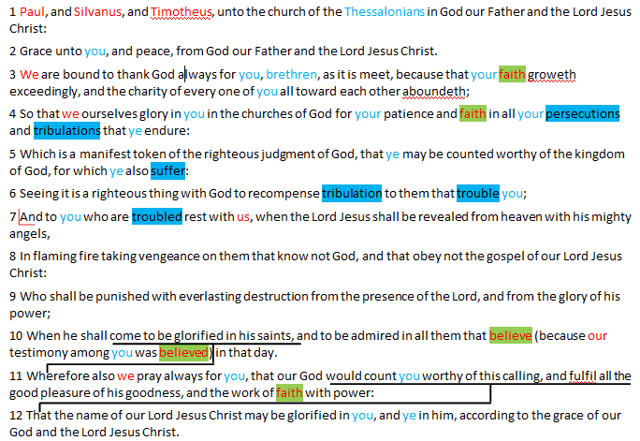

To do this, open the tab "Draw" on the ribbon *(Fig. 51).*

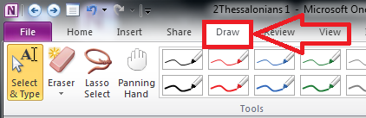

Please note that the software does not support OneNote IStudyBibleTools service "Pens". We recommend using other drawing shapes (lines, basic shapes).

## Search

If you know that certain notes are located in one of your notebooks, but you don’t remember their exact location, you can use the search function *(Fig. 52).*

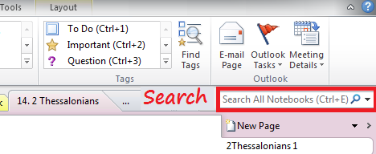

The first results will automatically be shown as you enter text into the search box. In the results list, you can navigate through pages using the mouse scroll wheel or arrow keys. As you scroll, an image appears for a preview of each page.

In addition, OneNote saves searches, so it is often sufficient to introduce only one or two letters until the correct page appears in the "Recent Picks" at the top results list *(Fig. 53).*

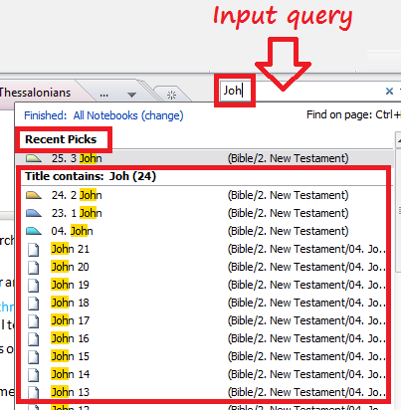

If you want to search for text in all notebooks, you can use the keyboard shortcut CTRL + E. If you want to find only text on a page, you can press the key combination CTRL + F and enter a search query. If you find multiple uses of the text, you can use the arrows to choose the right one *(Fig. 54).*

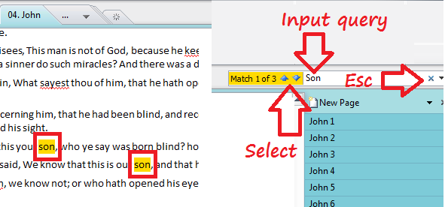

To cancel the search, press the small cross at the end of the field "Search" *(Fig. 54).*

Also in OneNote, you can view detailed information about the search results. To do this, open the search results *(Fig. 55).*

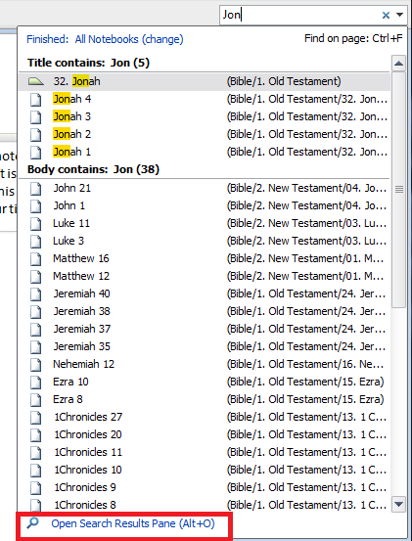

Here we can see exactly where the search word is found and sort search results *(Fig. 56).*

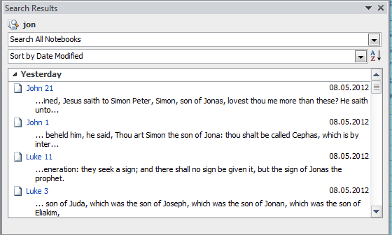

## Tagging

To create a tag in OneNote, move the cursor to the line containing the item you want to tag. Next, on the tab "Home", locate the group "tags" on the right side. Select one of your tags from the drop-down menu, such as "important" *(Fig. 57).*

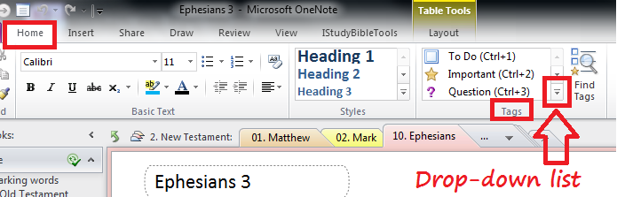

As a result, you can tag the line "Important" *(Fig. 58).*

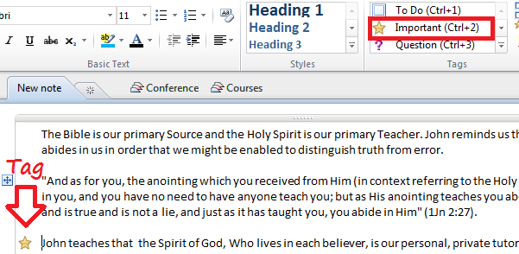

In the same group "Tags" tab "Home" select "Find Tags", and "Tags Summary" appears on the screen in the task pane *(Fig. 59).*

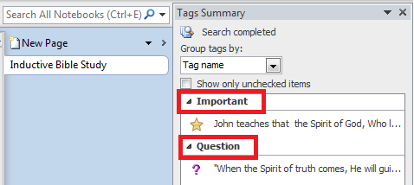

In the task pane "Tags Summary" groups all tags ("Important", "Question", etc.) and allows you to quickly and easily locate the desired note. To go to the desired article, click any tag in the summary.

If you want to compile a summary of tags for only part of the notes, or view notes recently marked, select another task pane at the bottom of the search "Tags Summary" *(Fig. 60).*

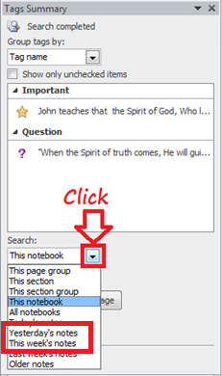

Tags can be customized in different ways, using the command "Customize Tags" at the end of the drop-down menu *(Fig. 61).*

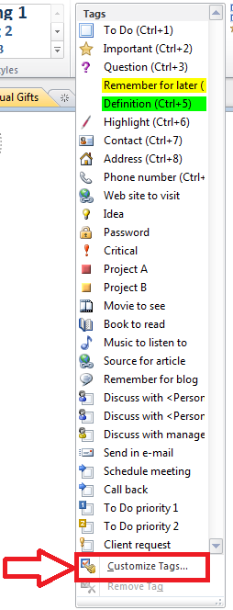

## Creating Hyperlinks

In OneNote, you can easily create a link to any existing page in your notebook. To create a link, right-click the selected text and choose "Link…" on the context menu *(Fig. 62).*

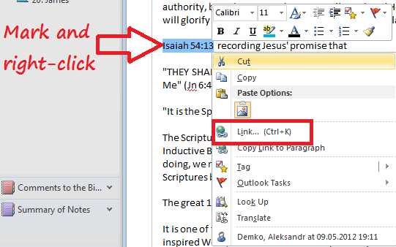

When you select this command, you can specify the text and address. You can also select a target to reference an existing page, section, or notebook *(Fig. 63).*

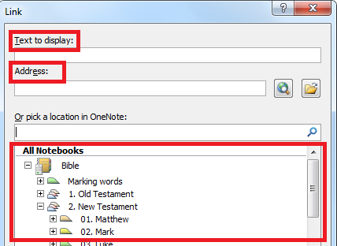

Use the expansion button, you can select the desired level of detail *(Fig. 64).*

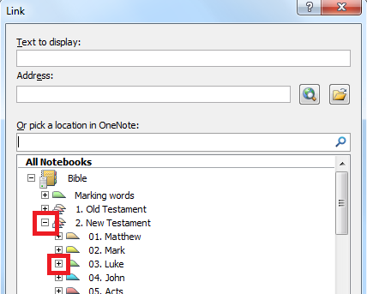

Note: When selecting a page, section, or notebook, the address in the "Address" changes accordingly. Using the search function, you can find an existing address book, chapter or page name *(Fig. 65).*

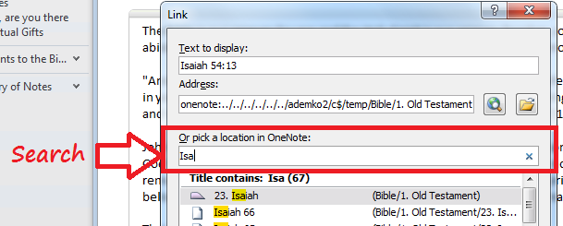

After selecting the desired location to move, press OK. A link to the specified location will be created. Now you can easily and quickly move to the right place using the link.

Another option for adding a hyperlink is to use the context menu command "Copy Link to Paragraph" *(Fig. 66)* and paste (Ctrl + V) a reference to this paragraph to the correct location.

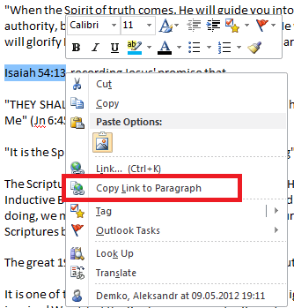

## Copy / paste

Each time you insert an object into a page of notes, (for example, if you copy a piece of text from one notebook *(Fig. 67)* and insert it into another) OneNote proposes to set parameters.

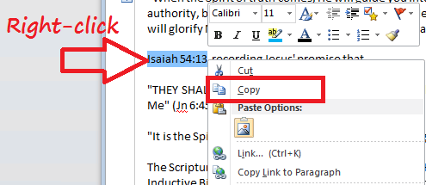

Depending on what you want to insert, these four parameters can be accessed in various combinations *(Fig. 68).*

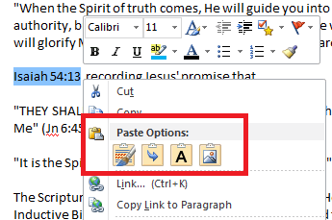

* Изображение значкаIf you select "Keep Source Formatting", the copied text is pasted to a new location while preserving the original formatting and appearance.
* Изображение значкаIf you select "Merge Formatting", inserted text will look exactly the same as the surrounding text.
* Изображение значкаIf you select "Keep Text Only", the text will be inserted into text format using OneNote by default (in this case, the font Calibri). In addition, if you choose "Keep Text Only" only editable text will be inserted without graphics, pictures and text, which is part of such an object, picture or screen clippings.
* Изображение значкаIf you select "Picture", you can paste all the copied contents into a single picture or a graphic, instead of text. In this case, the pasted text must be edited before it is pasted, since it is turned into a static image. It cannot be edited as text, although you can change the surrounding text.

Most other tools to copy and paste text, images, and other data are located on the ribbon on tab "Insert" *(Fig. 69).*

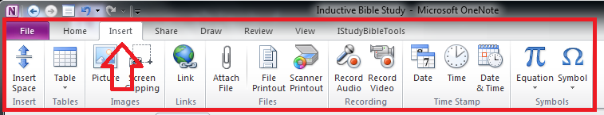

Also, remember that any frequently used control can be added to the Quick Access Toolbar *(Fig. 70).*

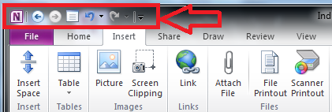

## Page Versions

Another very useful feature in OneNote is the ability to view an earlier version of a page and restore it if necessary *(Fig. 71 and Fig. 72).*

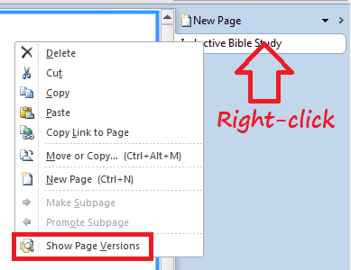

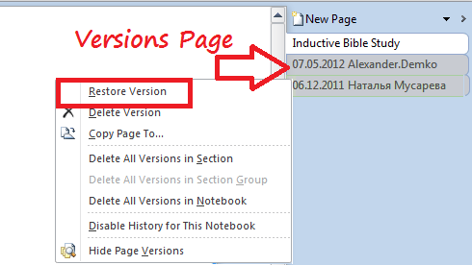

## Keyboard shortcuts in OneNote

### Working with text.

1. Ctrl+Alt +1/2/3/4/5/6/0 – to use one of the built-in styles of the current paragraph.
2. Ctrl+I - to use or cancel italic formatting of the selected text.
3. Ctrl+U - to use or cancel underline of the selected text.
4. Ctrl+B - to use or cancel the bold formatting of the selected text.

### Working with lists

1. Ctrl+dot (.) - to use or cancel formatting bulleted list of the current paragraph.
2. Ctrl+/ - to use or cancel the formatting of a numbered list of the current paragraph.
3. Tab – to increase the indent one level.
4. Shift+Tab - to reduce the indent one level.

### Working with tables

1. Tab - to create a table by adding a second column to have your input.
2. Ctrl+Enter – to create a line below the current line.
3. Alt+Enter – to create another paragraph in the same cell.
4. CTRL+ALT+E - insert a column to the left of the current column
5. CTRL+ALT+R - insert a column to the right of the current column
6. Move around the table

* Tab - moves the cursor to the next cell
* Shift+Tab - move the cursor to the previous cell

### Global commands

1. Win+Shift+N - open the OneNote
2. Ctrl+Z - undo the last action.
3. Ctrl+Y - redo the last action.
4. Ctrl+C - Copy selected text or item to the clipboard.
5. Ctrl+X - Cut the selected text or item to the clipboard.
6. Ctrl+V - paste the clipboard contents.
7. Ctrl+A - select all items in the current container.
8. F7 - check spelling.
9. F11 - enable or disable the full-page view.

### Working with Pages

1. Enter, when cursor is inside the link – go to the link.
2. Alt+back arrow – go back.
3. Alt+forward arrow – go forward.
4. Ctrl+PgDown - go to the next page of the section.
5. Ctrl+PgUp - go to the previous page of the section.

### Search for notes

1. Ctrl+E - search all notebooks.
2. Ctrl+F - Search only the current page.

# Description of Additional Program OneNote IStudyBibleTools

For the program OneNote IStudyBibleTools it is necessary to select the primary used module, which will be the base for the necessary notebooks with an appropriate translation of the Bible. You can download the modules from the website: <http://IStudyBibleTools.com/modules.htm>.

After installing the software in OneNote, it will show up an additional tab «IStudyBibleTools». When switching to the given tab, it will be accessible to a group of buttons "Tools", "Unlock Bible" and "Parameters" *(Fig. 73).*

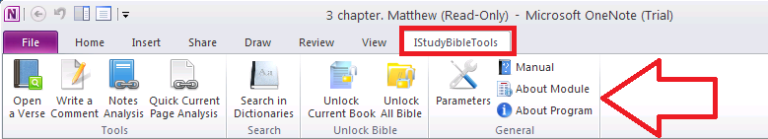

## Open a Verse

When you click on the button "Open Verse" appears appropriate window, it allows you to quickly jump to a specific verse from the Bible *(Fig. 74).*

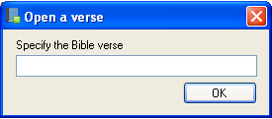

In this window you can type in a book and verse of the Bible, and click "OK". The program will automatically switch to the passage. You can specify one specific verse (Isaiah 55:5), chapter (Isaiah 55) or range (Isaiah 55:5-10). The program will take you to the first verse of the specified range. The program supports full book names as well as abbreviations (e.g. Isaiah or Is). It does not matter if you use lowercase and uppercase letters, but please note that the chapter and verse should be separated by a colon (Isaiah 55:3) or comma (Isaiah 55,3).

## Write a Comment

This function allows you to add a comment on any passage from the Bible or specific words in these passages.

### Comment on a chapter of the Bible

Suppose you are reading a chapter of a book, the Bible, and you need to write an explanation to this chapter. To do this, click on the "Write a Comment", following window will appear *(Fig. 75).*

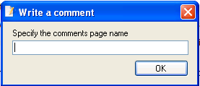

In this window, specify the name of the comment you want to insert in this chapter (e.g. List of "Jesus Christ" etc.). If you leave this field blank, you will create a note called "Comments". Click "OK". The program will create a note with the name you specified (by default "Comments") *(Fig. 76).*

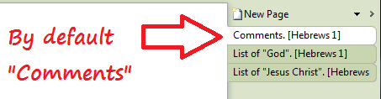

and automatically switch to this note. Now you can record any information you need on this chapter *(Fig. 77).*

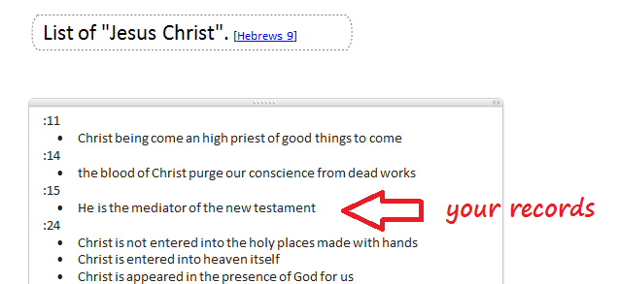

Note that when writing the name of a note in the window "Specify the page name", there is no need to specify a reference to the Bible chapter. The program does this automatically based on the passage in the Bible you selected by pressing the button "Write a Comment" *(Fig. 78).*

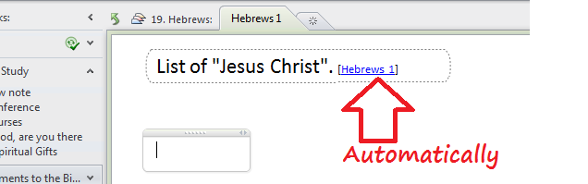

### Comments on a specific word in the Bible

If you need to add a comment not to the whole chapter, but to some words, or you want explain a verse, then select the text you want and click "Write a comment" *(Fig. 79).*

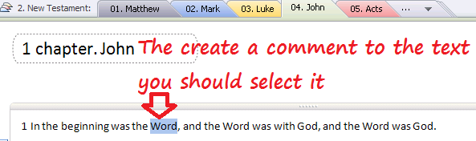

In the window "Write a comment", click "OK" *(Fig. 80).*



The program will make a note and automatically switches to it, so that you can make your explanation to the selected text *(Fig. 81).*

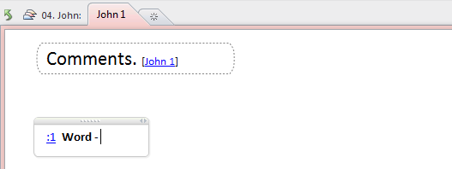

After entering the necessary information to the created note can be easily and quickly return to the place of the Bible, which you commented. This can be done in several ways:

* Click on the chapter *(Fig. 82)*

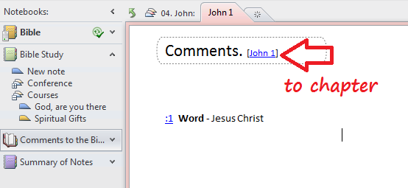

* Select the line*(Fig. 83)*

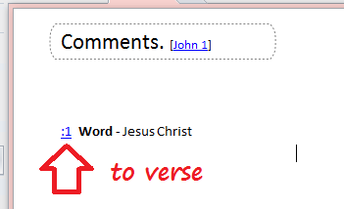

* Use the "Back" button *(Fig. 84)*

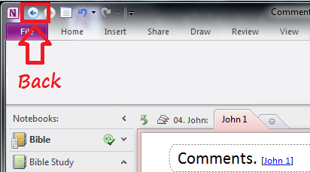

Note that after inserting a note to an underlined text, the text became a reference and the book of Bible became unlocked *(Fig. 85).*

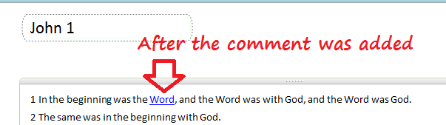

When adding commentary head on a Bible chapter, a reference to the added comment does not appear. For this to happen, you need to run the command "Notes Analysis".

## Notes Analysis

This function allows you to cross-reference all your notes to specific places in the Bible that are referred to in your notes. Any article you created contains a reference to a particular place in the Bible. In order that all of these records aren’t lost, you can fix each note to a Scriptural text. To do this, create a note, click on "Notes Analysis". A window will appear "Notes Analysis" *(Fig. 86).*

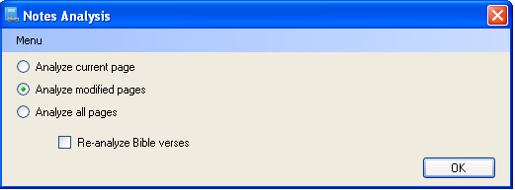

1. Analyze current page - the program will analyze only the page currently open in OneNote.
2. Analyze modified pages - the program will analyze only those pages that have changed since the last analysis of these pages.
3. Analyze all pages - the program will analyze all pages of your notebooks "Bible Study" and "Comments to the Bible". Note that in this case run time can be more than one hour.
4. Re-analysis Bible verses - re-analysis of scriptures, even if they have already been analyzed previously. This option is used in the following two cases:
   * when you move the notes;
   * when re-linking notes after the operation "Delete all ‘Summary of Notes’ pages" (the details of the transaction can be found under "Parameters").

After selecting the appropriate option, click "OK". The program will begin processing notes *(Fig. 87).*

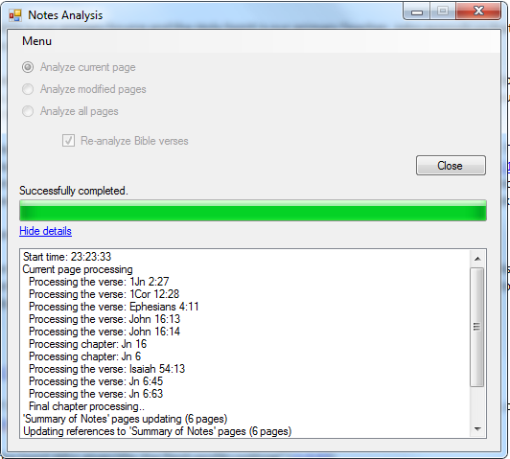

If nonexistent Bible verses are mentioned in notes (for example, Romans 56) then the program will finish the analysis with warnings *(Fig. 88)*.

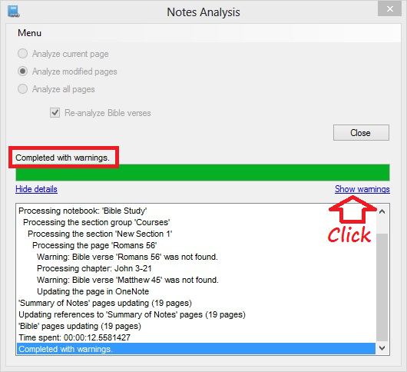

When you click on the link "Show warnings", the form with not found verses will open. When you click on the not found verse, the paragraph in which this verse is mentioned will open *(Fig. 89)*.

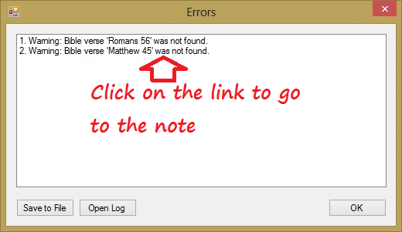

After the program finishes analyzing the notes, it provides you with all locations in the Bible for each given reference *(Fig. 90).*

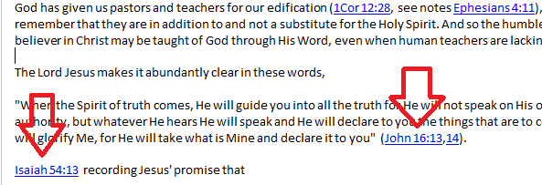

By clicking on one of the links, you can quickly move to the associated text of the Bible. After starting the command, you will see a link "Notes" next to the verses listed in the test article *(Fig. 91).*

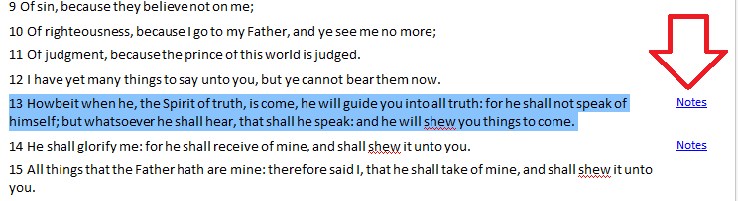

When you click on the link "Notes", the form "Summary of Notes" will open. Here you can see the notes on which this verse is mentioned and go to this note *(Fig. 92).*

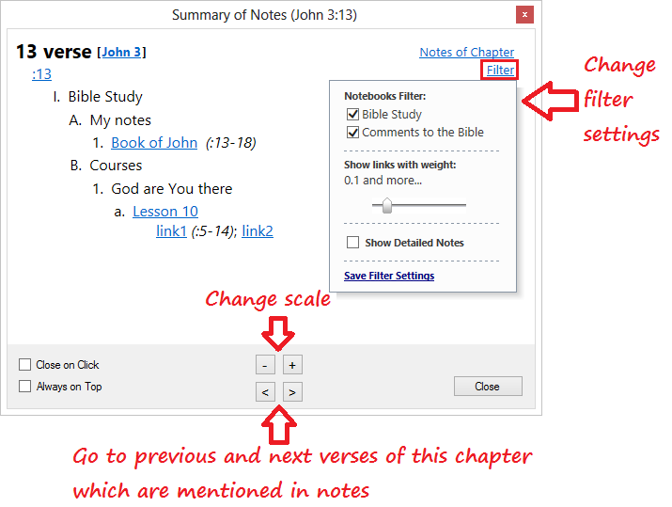

You can set a filter for list of notes on the “Summary of Notes” form. There are three available filters:

* Notebooks filter. You can select Notebooks for which its notes should be visible on the form. If you use only one Notebook this filter will be hidden.
* Filter on verses weight. Each Bible verse mentioned in note has its own importance (verse weight). So if you have mentioned only one verse – the verse weight will be equal to 1. If you have mentioned a range of verses – the weight of each verse in this range will be equal to 1 divided to range’s verses count. If you have mentioned verse or range of verses as important verse (for instance, *John 3:16*), the verse weight will be equal to 2. With this filter you can specify the minimal value for verses weight which should be visible on the form.
* Filter on detailed notes. You can show or hide detailed notes. Links to detailed notes have gray text color.

Click “Save Filter Settings” to save the changes of filter settings.

The "Summary of Notes" page has the following structure *(Fig. 93)*:

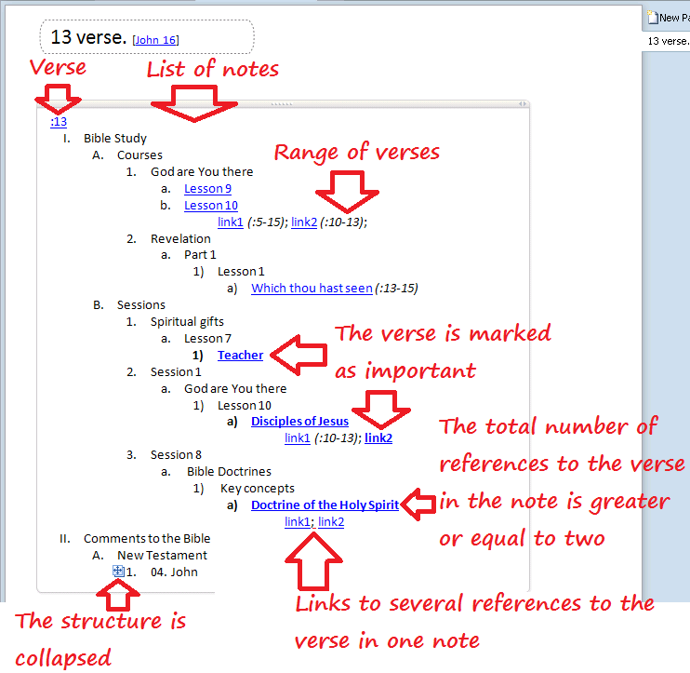

* Verse of chapter.
* List of notes that reference the verse.
* In round brackets the range of verses used in the note, including this verse.
* If a note has several references to the same Bible verse, then every reference to the verse forms a separate link.
* If the total number of references to the verse in the note is greater or equal to two, the reference to this note is marked in bold.
* The link to the note where the verse is marked as important by asterisks also is marked in bold. For details see the section "Recommendations".
* The structure is collapsed when you specify a certain number of displayed levels in the form of selecting notebooks for analysis. In this example, the number of displayed levels for the notebook "Comments to the Bible" equals to three. To see the entire structure double click on the icon to the left of the collapsed element.

Notice the "Menu" button in the window, "Notes Analysis" *(Fig. 94)*.

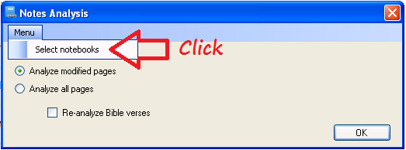

When you press it, you can then use "Select notebooks for the analysis". By default, the two notebooks: "Bible Study" and "Comments to the Bible" are selected *(Fig. 95)*.

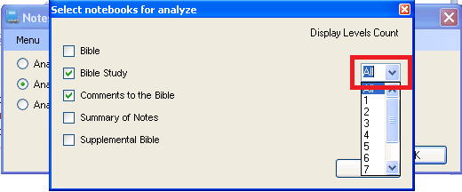

To select notebooks, place a checkmark in the box next to the notebook name. Here you can specify the number of displayed levels that are shown on page "Summary of Notes".

## A quick analysis of the current page

It is allowed to start "Analysis notes" on the current note without its linkage to the specific places of the Bible. Upon completion of its work, the program will provide for the current page all known passages from the Bible as a reference. Clicking on one of the links, you can easily and quickly go to the Bible text.

Please notice that the note is not attached to the Bible in this case. And that is, after the command has been started, next to the verses the link "Notes" will not appear. You must run "Analysis notes" for the connection.

## Search in dictionaries

With the command "Search in dictionaries", located on the tab «IStudyBibleTools», you can quickly and easily search for the words you are interested in all dictionaries, added to the program (*Fig. 96*).

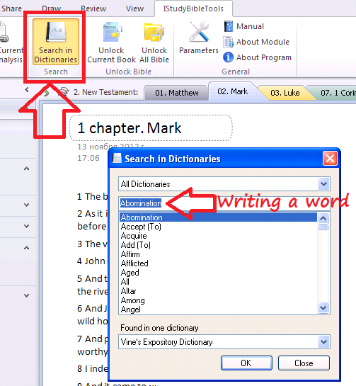

## Unlock the current book / Unlock the Bible

It is allowed to unlock the current book or the entire Bible. By default, all notebook "The Bible" is locked. After unlocking you can work with the text of the notebook: mark key words, contrasts, comparisons, titling chapters, paragraphs, etc.

To understand whether the current book of the Bible is unlocked or not, you can move the cursor to the "New Page" button. If the current book is unlocked, the button will be active *(Fig. 97 and Fig. 98).*

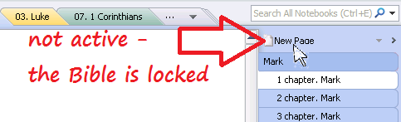

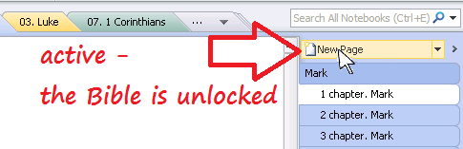

Please notice that "relock" will be carried out only after closing the application OneNote.

Locking the Bible which is stored in SkyDrive is not supported. It is recommended to use the services such as Google Drive, Dropbox, etc., in which you can save the notebook Bible as a normal folder. In this case, the locking of the Bible will work.

## Parameters

This function allows you to change the program parameters.

1. OneNote Parameters *(Fig. 99)*. Allows you to select or create notebooks for the Bible, for notes related to the Bible study, for comments to the Bible and for "Summary of notes" pages. It is recommended to store "Summary of notes" pages in a folder for performance and usability improvements.

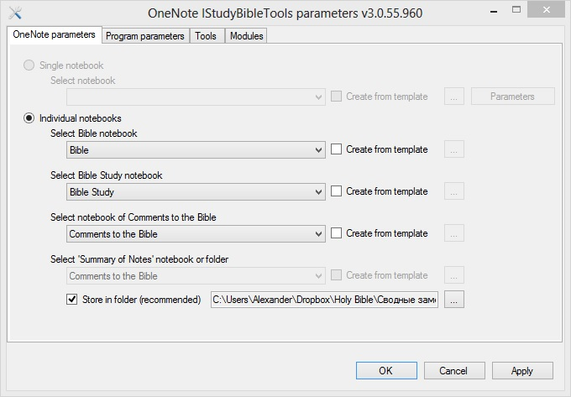

1. Program parameters *(Fig. 100).* Allows you to change some features of the program:
   * The names of pages of commentary to the book and the chapter by default.
   * Page Setup "Summary of Notes":
     + Name.
     + Width.
     + Analyze each verse in range - in the case of notes for a range of verses (e.g. Mt 5:1-4), a note will link to all verses included in the range (i.e. Mt 5:1,2,3,4).
     + Analyze excluded verse and chapter- analyzed by all the verses and chapters listed in the notes that, regardless of the exceptions listed in section "Recommendations".
     + Individual pages for each verse - in the notebook "Summary Notes" list of links to notes for each verse will be placed on an individual page.
   * Change the page settings "Detailed Summary of Notes".
     + Name.
     + Width.
     + Analyze each verse in range.
     + Analyze excluded verse and chapter.
   * Use the default values. If you have problems after changing settings on this tab, you can always return to the initial parameters of the program.
   * Language of the interface. It is allowed to choose the language of the program: English or Russian.

Please note, if you change any setting on this tab, you must run "Notes Analysis", with options "Analyze all pages" and "Re-analysis Bible verses".

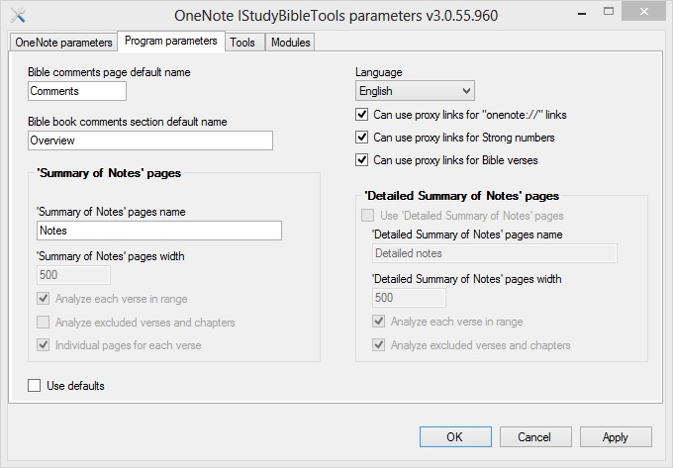

Please note that parameters related to analyze and to page "Detailed Summary of Notes" are not accessible if pages "Summary of Notes" are stored in a folder.

1. Tools *(Fig. 101).C*ontains additional tools to work with the program.
   * Update references to the comments. Sometimes the comments of the Bible do not have precise references (not to a specific comment, and comments on the page). To resolve this problem, we recommend periodically using this tool.
   * Delete all "Summary of Notes" pages- the program will remove all references to the Bible. Note that only the page "Summary of Notes" and links to the pages of the Bible will be deleted. The text notes, comments, and references to the Bible will remain. After this operation, the program "Notes Analysis" should be run by using "Re-analysis Bible verses".
   * Change Bible pages width. The default range of all the pages in your notebook "Bible" is 500. You can change the size of the notebook as you wish, given the size of your monitor.
   * Create a backup of the data. This allows you to create a backup copy of data notebooks that are used to study the Bible. We recommend using this utility at least once a month.

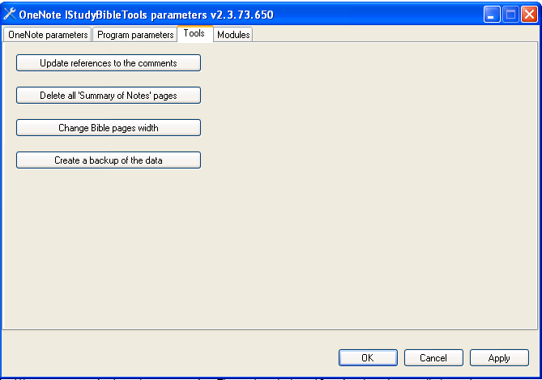

1. Modules *(Fig. 102)*. It is allowed to manage the modules of the program OneNote IStudyBibleTools. To download modules, please visit <http://IStudyBibleTools.com/modules.htm>.

Please take notice that the Supplemental Bible and Dictionaries are only available for modules version 2.0 and higher. If you already have an earlier version of the module, it is recommended to upgrade. Information (all of your notes, comments, marked words in the Bible) will not be lost after updating the module.

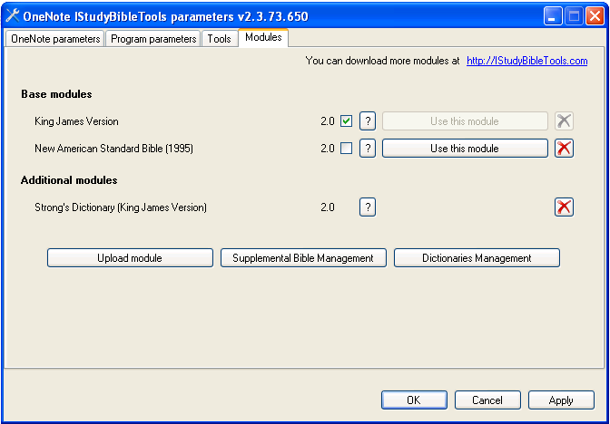

* + Adding modules.
* The base modules. Only on the basis of one of the base modules notebooks "Bible”, "Bible Study", "Comments to the Bible" and "Summary of Notes" can be set up. To select the base module for the program OneNote IstudyBibleTools you must
  + open the downloaded module file by double click or use the "Add Module";
  + after the appearance of the module on the tab "Modules" click "Use this module" next to the desired module.

If you change the used module, it is necessary to renew the notebooks, "Bible", "Comments to the Bible" and "Summary of Notes". Consequently, the base module of program OneNote IstudyBibleTools can be one. All other modules from the group "Base modules" can be used in a notebook "Suuplemental Bible", which allows you to see multiple translations of the Bible at the same time (in parallel).

* Additional modules. Additional modules can be used only in notebooks "Supplemental Bible" and "Dictionaries". Module from the list cannot be used as a base module. Please take notice that module of the Bible with Strong's Dictionary is an additional module.

Please note that you can use Bible books shortenings from another module immediately after uploading this module to OneNote IStudyBibleTools. For example, you can use Russian shortenings of Bible books immediately after RST module uploading. And the program will take care about the differences of structure of Bible chapters and verses of different Bible translations.

* + Supplemental Bible management.
* Notebook "Supplemental Bible" provides the possibility to use multiple parallel translations (modules). To set up this notebook you must click on the "Supplemental Bible Management" and click the checkbox "Use notebook ‘Supplemental Bible’" in the opened window. (*Fig. 103*).

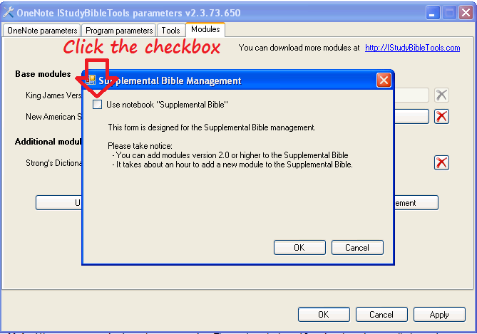

* You can set up a new notebook "Supplemental Bible" or use an existing notebook, which you have already created. You can also specify a folder in which to set up this notebook. (*Fig. 104*).
* In order to add a translation of the Bible in this notebook "Supplemental Bible", it is necessary to press the small black triangle and select from the list the needed translation (*Fig. 104*). Please take notice that it is impossible to add twice the same translation in the notebook "Supplemental Bible". After selecting the translation from the list, you must click "OK". To add another translation, you need to repeat the operation. Adding translation takes about an hour.

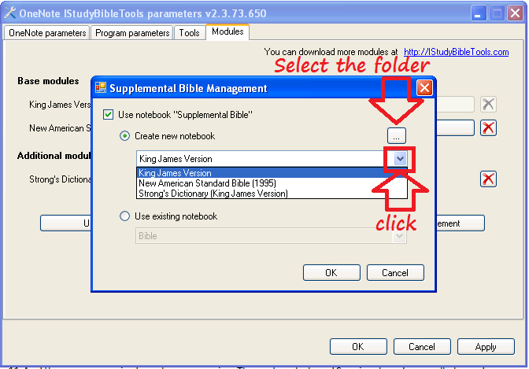

* After setting up the notebook "Supplemental Bible" in the notebook "Bible", from the right of each verse, a link "SB" will refer on the corresponding verse of notebook "Supplemental Bible" (*Fig. 105*).

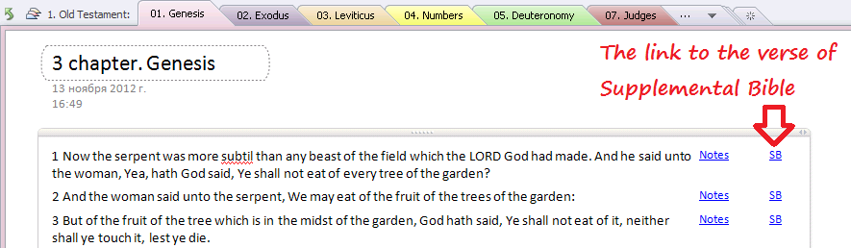

* The number of each verse of notebook "Supplemental Bible" is a reference to the verse of notebook "Bible" (*Fig. 106*).

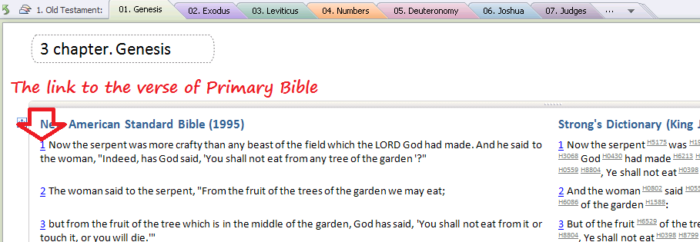

* By default notebook "Supplemental Bible" is locked. For work with text: marking the key words, contrasts, comparisons, headlining chapters, paragraphs, and so on - it is recommended to use the notebook "Bible". Please take notice that after setting up this notebook, as a notebook "Bible", will be unlocked right away.
* When adding to the notebook "Supplemental Bible" module of the Bible with Strong's Dictionary, the Strong's dictionary will be automatically added to your notebook "Dictionaries." When clicking on the Strong's number in the notebook "Supplemental Bible" a transition will be carried out to a description of the Strong's number in the notebook "Dictionaries" (*Fig. 107*).

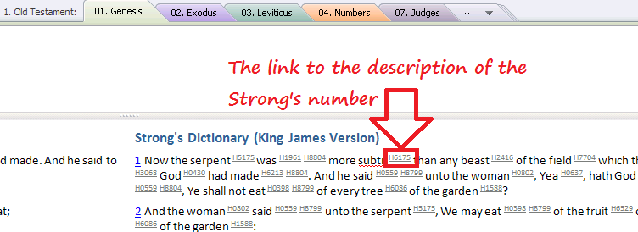

* Moreover, on this page you can add your own notes for each Strong's number and find all the references of Strong's number in the Bible, (*Fig. 108*).

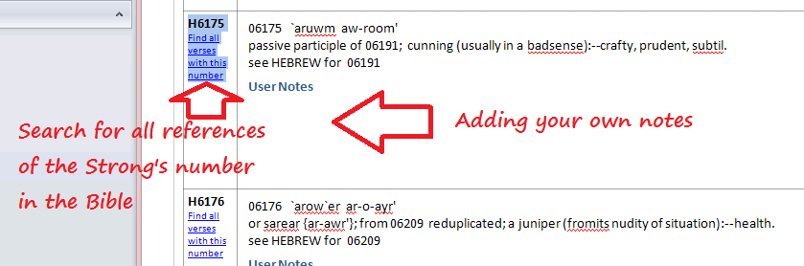

* When you search for all references of Strong's number in the Bible, it is recommended to choose sorting by section in the "Search Results" (*Fig. 109*). In this case, all references of this number will be grouped by the books and chapters of the Bible.

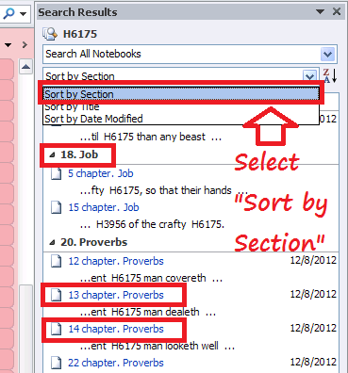

* When choosing any chapter of the Bible, a transition will carry out on the page of the Bible, in which are highlighted all references of the Strong's number in the chapter (*Fig. 110*).

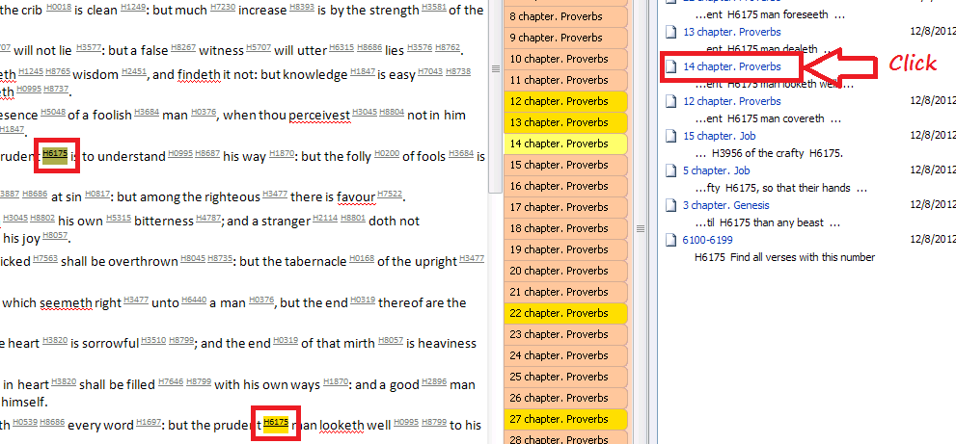

* To remove one of the modules in your notebook "Supplemental Bible", press the cross to the right of the module (*Fig. 111*). Please take notice that the first module of the notebook "Supplemental Bible" can not be removed (the cross on the right is not active). In this case, you must close your all notebook "Supplemental Bible".

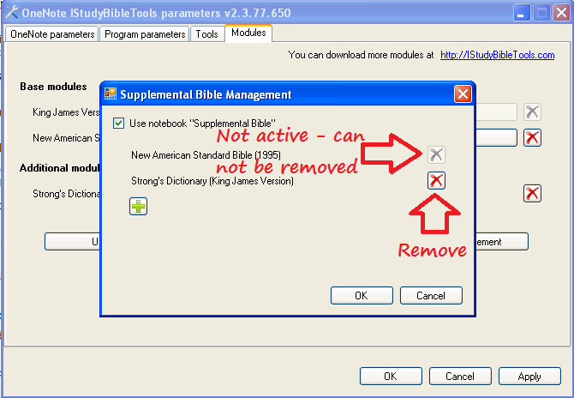

* To close (delete) the entire notebook "Supplemental Bible", it is necessary to uncheck the checkbox "Use notebook ‘Supplemental Bible’" (*Fig. 112*).

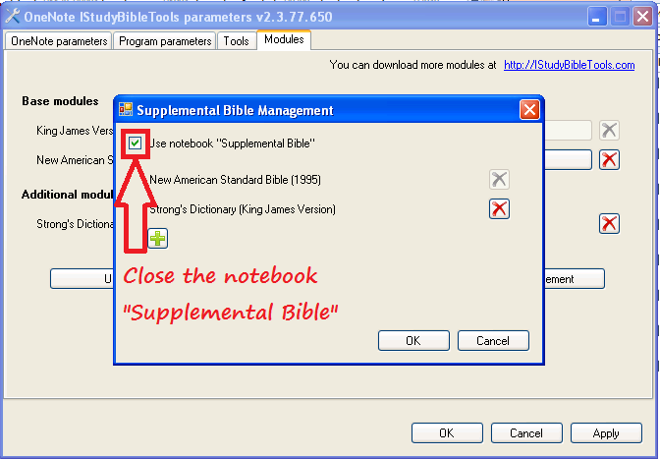

* + Dictionaries management
* To add a dictionary to OneNote IStudyBibleTools, you must click on the "Dictionaries Management" on the tab of "Modules" and click the checkbox "Use notebook ‘Dictionaries’" (*Fig. 113*). Dictionaries are added to the notebook "Dictionaries".

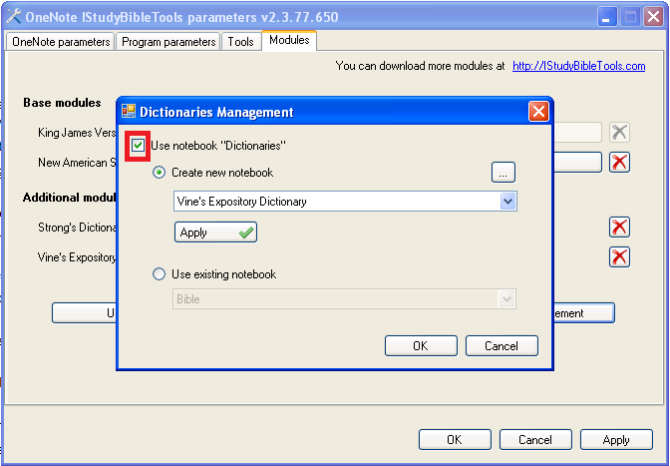

* To remove any dictionary press the cross to the right of the module. To close the notebook "Dictionaries", you must uncheck the checkbox "Use notebook ‘Dictionaries’" (*Fig. 114*).

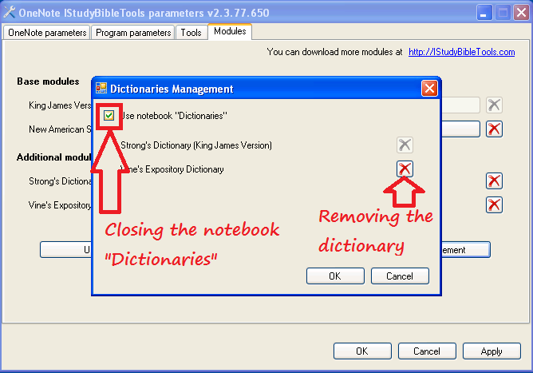

## Information

Provides instructions for using the OneNote and additional program OneNote IStudyBibleTools for independent Bible study. This documentation opens in Microsoft Office Word.

## About Module

Show information about the current module and about the supported abbreviations. These abbreviations can be used in the text notes or when you run the command "Open Verse" (*Fig. 115*)

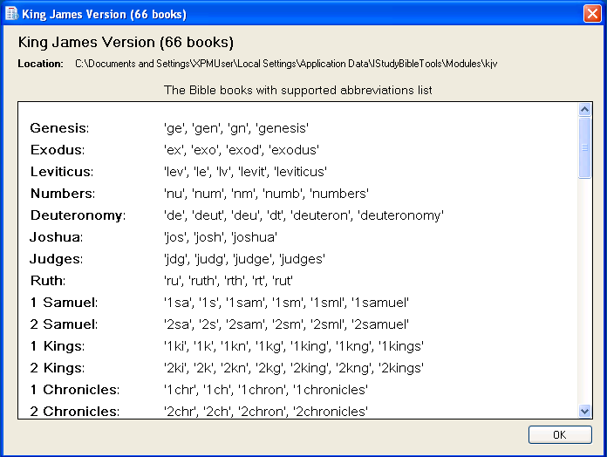

## Recommendations

For normal operation of the program or creating a note, follow these guidelines:

1. If the note is frequently repeated in the same chapter, it can be specified by using square brackets in the title of the article *(Fig. 116).*

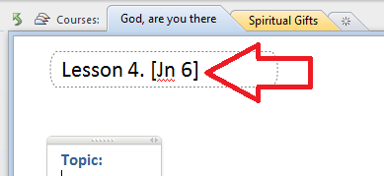

In this case, the program would not bind a note to each verse of this chapter, but only to the Bible chapter itself *(Fig. 117).*

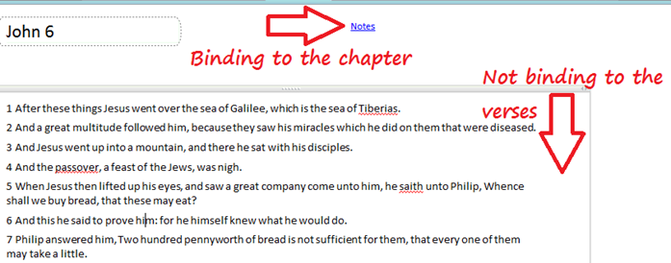

If there are a few chapters, you can specify all of them in square brackets in the heading *(Fig. 118).*

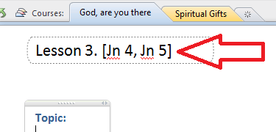

Note that in the article, verses still stand out as a reference. If you assign a note to a particular verse, then the chapter where the verse is located is specified in the header of bracketed note. However, you must also specify the verse in square brackets *(Fig. 119).*

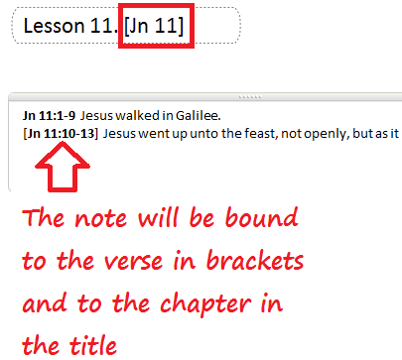

1. If you do not want to a note to be linked to the whole Bible, use the curly or square braces: {} or [] *(Fig. 120).*Note that the braces are specified with no space between them.

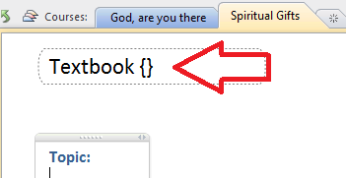

If you do not want to link a note to a particular verse only, you must specify the desired book, chapter, and verse please using the curly brackets. For example, {1 Cor 13:2}.

If you do not want to a whole section, section group or notebook to be linked to the Bible, use square braces [] in a title of section, group section or notebook *(Fig. 121).*

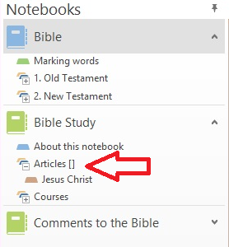

Note that, in the link, verses still stand out as a reference, but in the "Summary of Notes" link they will not be visible. However, they can be seen in the "Detailed Summary of Notes".

1. If the title of a note indicates a particular chapter of a book of the Bible (in square brackets or not), then the note itself can be located without specifying the chapter (e.g. ":15"). In this case, all the verses are tied to the chapter that is referenced in the title, unless otherwise specified in the chapter.
2. If you want to mark the verse in the note as important, mark the verse with an asterisk (for example, *John 3:16*). In this case the link to this note on page "Summary of Notes" will be marked in bold.
3. When specifying scriptural locations, use the following format: name of the book (or abbreviation) followed by a space, chapter number, colon, verse number or range of verses separated by a hyphen (e.g. John 3:16 and 1Corinthians 1Peter 3:1-5).
4. When you create lists it is recommended that you **first** indicate the name of the book and then chapter number and verse separated by a colon *(Fig. 122 and Fig. 123).* In this case, the link will exist only for verses in the stated chapter number. If the book and chapter number are not stated in the beginning of a verse, the link will not be made to this chapter and verse.

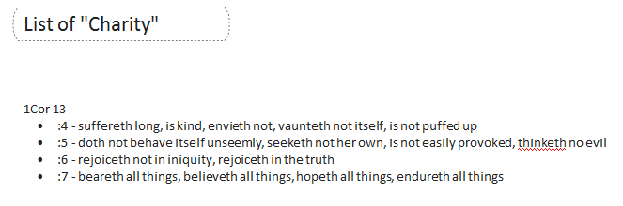

or

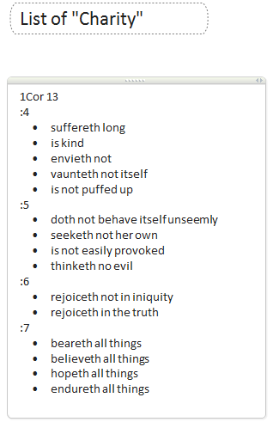

1. Similarly, when creating tables, the name of the book and chapter number must be specified in each cell of the table *(Fig. 124).*

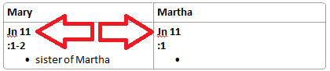

1. Links from the Bible can be specified as the book and chapter. For example, John 5. In this case, the program will make a binding only to the chapter of the book that you have specified.
2. If you need to specify a link to a variety of verses (not consecutive) in one chapter, it is possible to list them separated by commas with no spaces. For example, John 5:8,13-15,18.
3. For a specified range of verses (e.g. John 3:15-20), the note will not be specific to a given verse within the stated range (e.g. ":16"). The note will link only to the specified range of verses. If the stated verse does not fall within the given range (e.g., ":21"), then no link will exist to this verse.
4. The program does not support creating links for ranges such as "John 1:30-2:5", "John 1:30, 2:5" and "John 1-2".
5. If you want to link a note to

* all chapters and verses mentioned in the article (ignoring the exceptions listed above), or,
* all verses within the specified ranges,

you can use the options "Analyze excluded verse and chapters" and "Analyze each verse in range" discussed in the section "Parameters". In addition, you can use a two summary of notes pages: "Summary of Notes" and "Detailed Summary of Notes." For each of the pages, you can specify the granularity of the analysis notes. Please note that references from the Bible in the summary of notes pages are always only on the page "Summary of Notes".

1. For your convenience, a template program OneNote IStudyBibleTools in the notebook "Bible" includes a section "Marking words" *(Fig. 125)*.

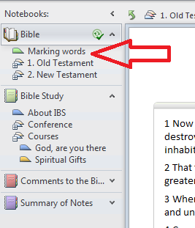

Initially, this section contains a few words selected in a certain way *(Fig. 126)*.

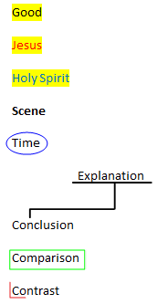

Copying the format of any word can save you time on stage "Observation" inductive Bible study in the allocation of keywords contrasts, comparisons, contrasts, references to time, place of action.

* Copying the format of a keyword.
  1. Find the keyword whose format you wish to copy in the study the Bible passage, go to "Marking words".
  2. Choose the word whose format you want to copy *(Fig. 127).*
  3. In the "Home" click on "Format Painter". The pointer will change into a brush.
  4. Go to the Bible passage being studied and click on the keyword to which you desire to apply the formatting. To apply formatting to more than one keyword found, and to a few words, double-click the "Format Painter".

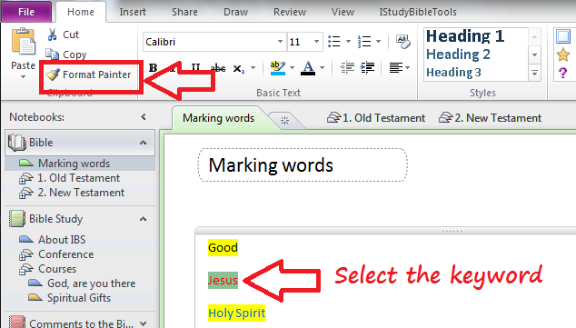

* Copying graphics.
  1. Noting, for example, an indication of the time studied the Bible passage, go to "Marking words".
  2. Select the graphic that accompanies the word "Time" (oval), copy one of the methods known to you, such as using the keyboard shortcut Ctrl + C.
  3. Go to the Bible passage being studied and paste the copied object, such as using the keyboard shortcut Ctrl + V.
  4. Move the pasted object to the found word.
  5. Use the mouse to resize if necessary.

The proposed version of the selection of keywords is not required. You can also use the tab "Paint" to change the format of a keyword. The section can be supplemented by other key words and used with page "Bible". This will help you identify key words in the Bible the same way.

1. If you need to headline the topic of chapter in the Bible, first of all, you need to unlock the current book or all the Bible. Then set up the cursor in the beginning of the first line, and press ENTER *(Fig. 128)*. Now you can impose the topic of the chapter.

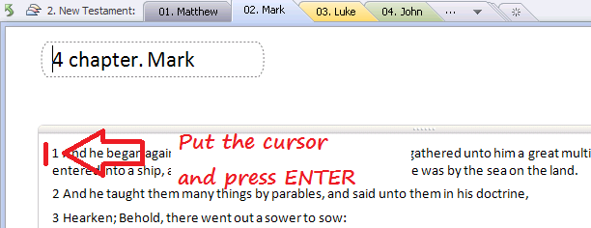

Similarly, you can define the topic of the paragraphs. In this case, the cursor must be set before the beginning verses of the paragraph *(Fig. 129)*.

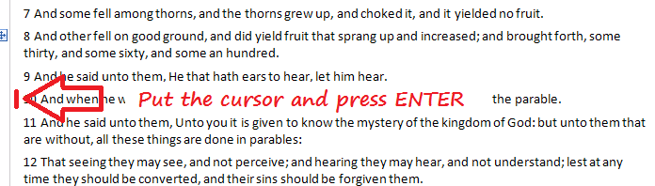

In order not to coalesce the topics of chapters and paragraphs with the text of the Bible, they can be selected by changing the style to "Heading 1," "Heading 2," or "Heading 3", which are located on the tab "Home" *(Fig. 130)*.

The result of the indication of chapter and paragraphs topics is shown below *(Fig. 131)*.

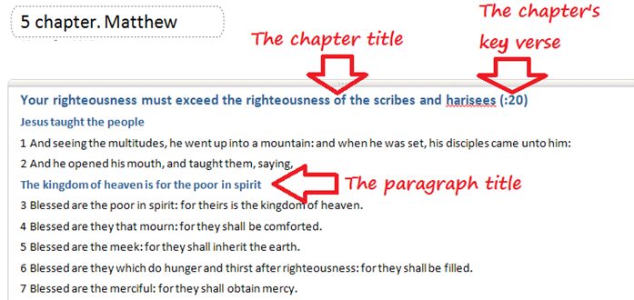

# Frequently Asked Questions

* **What if there is no visible tab labeled IStudyBibleTools?**

If the program OneNote IStudyBibleTools is installed on your computer, but no tab labeled "IStudyBibleTools" appears in the OneNote, it is possible that one of the following has happened:

1. You have installed an inappropriate version of OneNote IStudyBibleTools. For example, you may have installed Microsoft Office **x64**, and you have installed OneNote IStudyBibleTools **x86**. In this case, you will need to remove the current version (**x86**) of OneNote IStudyBibleTools and then install the required version (**x64**).
2. Sometimes there are different kinds of unexpected errors when loading the program OneNote and the IStudyBibleTools. In such cases, please go to OneNote settings in OneNote, select "Add-Ins", click "Go" *(Fig. 132)* and make sure that "OneNote IStudyBibleTools" is checked *(Fig. 133).*

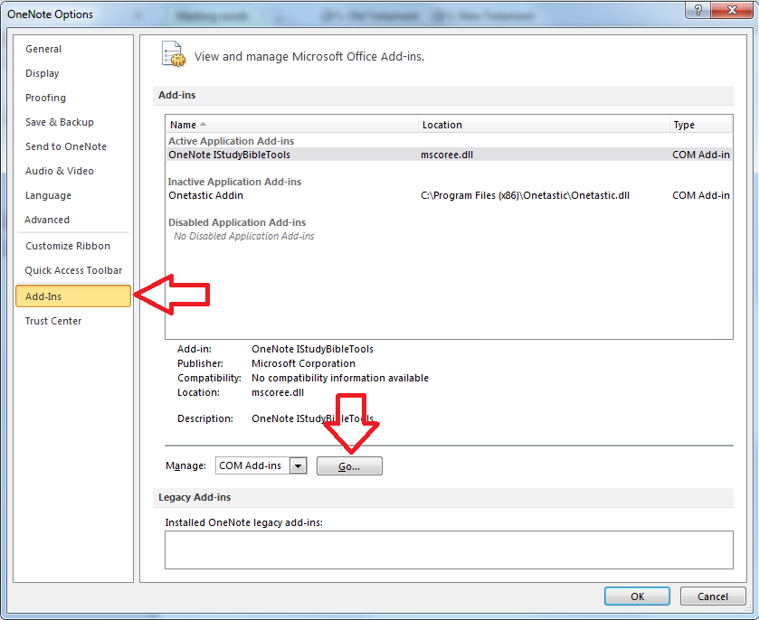

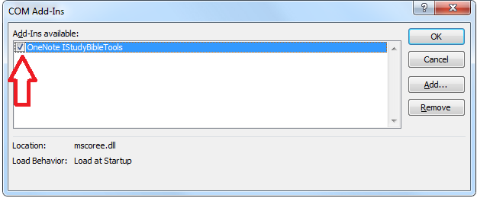

1. Make sure that all the necessary components of an application Microsoft OneNote are installed *(Fig. 134).*

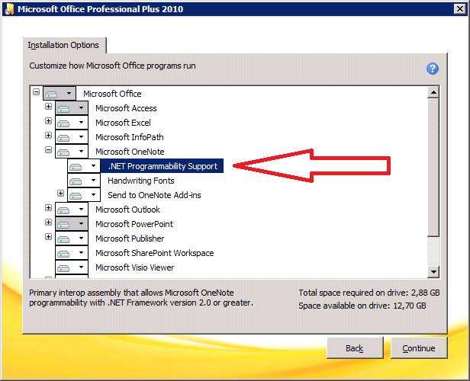

* **What if the program raises the error «0x80042001» while creating the Supplemental Bible?**

It seems that the latest Windows updates are not installed on your computer. Check the settings of the Windows Update in the Control Panel.

* **Can I use this program on computers with Mac OS?**

Yes, if you install Windows on virtual machine using one of the programs: Parallels Desktop, VMware Fusion, Virtual Box. And in Windows you can install Microsoft Office OneNote 2010/2013 and the program OneNote IStudyBibleTools. Please consider the following recommendations:

1. It is recommended that on your computer should be at least 4 GB RAM.
2. It is recommended to change in OneNote the default notebooks folder path (File -> Options ‑> Save & Backup -> Default Notebook Location) before installing and configuring OneNote IStudyBibleTools. You should specify the local folder path. Otherwise there can be problems when saving notebooks data.

Please send all questions or comments via email to: [support@IStudyBibleTools.com](mailto:support@IStudyBibleTools.com).

1. SkyDrive - is a service from Microsoft for storing files on the Internet. You can read more about SkyDrive at the following link <http://skydrive.com>.
2. Windows Live ID is an account used as a single login for all network services provided by Microsoft.